Evaluating the Performance of Publish/Subscribe Platforms for
Information Management in Distributed Real-time and Embedded Systems
Ming Xiong, Jeff Parsons, James Edmondson, Hieu Nguyen, and Douglas C Schmidt,
Vanderbilt University, Nashville TN, USA

Abstract
Recent trends in distributed real-time and embedded (DRE) systems motivate the need for information management capabilities that ensure the right information is delivered to the right place at the right time to satisfy quality of service (QoS) requirements in heterogeneous environments. To build and evolve large-scale and long-lived DRE information management systems, it is necessary to develop standards-based QoS-enabled publish/subscribe (pub/sub) platforms that enable participants to communicate by publishing the information they have and subscribing to the information they need in a robust and timely manner. Since there is little existing evaluation of the ability of these platforms to meet the performance needs of DRE information management systems, this paper provides two contributions: (1) it describes three common architectures for the OMG Data Distribution Service (DDS), which is a standard QoS-enabled pub/sub platform and (2) it evaluates implementations of each of these architectures to investigate their design tradeoffs and compare their performance empirically, both with each other and with other pub/sub middleware. Our results show that DDS pub/sub implementations perform significantly better than standard non-DDS pub/sub alternatives and are well-suited for certain classes of data-critical DRE information management applications.

Keywords: Information Management in DRE Systems; QoS-enabled Publish/Subscribe Platforms; Data Distribution Service;

Introduction
Mission-critical distributed real-time and embedded (DRE) applications increasingly run in systems of systems, such as the Global Information Grid (GiG) [11], that are characterized by thousands of platforms, sensors, decision nodes, and computers connected together to exchange information, support collaborative decision making, and effect changes in the physical environment. For example, the GIG is designed to ensure the right information gets to the right place at the right time by satisfying end-to-end quality of service (QoS) requirements, such as latency, jitter, throughput, dependability, and scalability. At the core of DRE systems of systems are data-centric QoS-enabled publish/subscribe (pub/sub) platforms that provide
- Universal access to information from a wide variety of sources running over a wide variety of hardware/software platforms and networks,
- An orchestrated information environment that aggregates, filters, and prioritizes the delivery of this information to work effectively in the face of transient and enduring resource constraints,
- Continuous adaptation to changes in the operating environment, such as dynamic network topologies, publisher and subscriber membership changes, and intermittent connectivity, and
- Various QoS parameters and mechanisms that enable applications and administrators to customize the way information is delivered, received, and processed in the appropriate form and level of detail to users at multiple levels in a DRE system.
Conventional Service-Oriented Architecture (SOA) middleware platforms have had limited success in providing these capabilities, due to their lack of support for data-centric QoS mechanisms. For example, the Java Messaging Service for Java 2 Enterprise Edition (J2EE) [10] is a SOA middleware platform that is not well-suited for DRE environments due to its limited QoS support, lack of real-time operating system integration, and high time/space overhead. Even conventional QoS-enabled SOA middleware, such as Real-time CORBA [9], is poorly suited for dynamic data dissemination between many publishers and subscribers due to excessive layering, extra time/space overhead, and inflexible QoS policies.
To address these limitations—and to better support DRE information management—the Object Management Group (OMG) has recently adopted the Data Distribution Service (DDS) [6] specification. DDS is a standard for QoS-enabled pub/sub communication aimed at mission-critical DRE systems. It is designed to provide (1) location independence, via anonymous pub/sub protocols that enable communication between collocated or remote publishers and subscribers, (2) scalability, by supporting large numbers of topics, data readers, and data writers, and (3) platform portability and interoperability, via standard interfaces and transport protocols. Multiple implementations of DDS are now available, ranging from high-end COTS products to open-source community-supported projects. DDS is used in a wide range of DRE systems, including traffic monitoring [], controlling unmanned vehicle communication with their ground stations [16], and in semiconductor fabrication devices [].
Although DDS is designed to be scalable, efficient, and predictable, few publications have evaluated and compared DDS performance empirically for common DRE information management scenarios. Likewise, little published work has systematically compared DDS with alternative non-DDS pub/sub middleware platforms. This paper addresses this gap in the R&D literature by describing the results of the Pollux project, which is evaluating a range of pub/sub platforms to compare how their architecture and design techniques affect their performance and suitability of DRE information management. This paper also describes the design and application of an open-source DDS benchmarking environment we developed as part of Pollux to automate the comparison of pub/sub latency, jitter, throughput, and scalability.
The remainder of this paper is organized as follows: Section 2 summarizes the DDS specification and the architectural differences of three popular DDS implementations; Section 3 describes our ISISlab hardware testbed and open-source DDS Benchmark Environment (DBE); Section 4 analyzes the results of benchmarks conducted using DBE in ISISlab; Section 5 presents the lessons learned from our experiments; Section 6 compares our work with related research on pub/sub architectures; and Section 7 presents concluding remarks and outlines our future R&D directions.

Overview of DDS

Core Features and Benefits of DDS
The OMG Data Distribution Service (DDS) specification provides a data-centric communication standard for a range of DRE computing environments, from small networked embedded systems up to large-scale information backbones. At the core of DDS is the Data-Centric Publish-Subscribe (DCPS) model, whose specification defines standard interfaces that enable applications running on heterogeneous platforms to write/read data to/from a global data space in a DRE system. Applications share information with others can use this global data space to declare their intent to publish data that is categorized into one or more topics of interest to participants. Similarly, applications that want to access topics of interest can also use this data space to declare their intent to become subscribers. The underlying DCPS middleware propagates data samples written by publishers into the global data space, where it is disseminated to interested subscribers [6]. The DCPS model decouples the declaration of information access intent from the information access itself, thereby enabling the DDS middleware to support and optimize QoS-enabled communication.
Topic
Topic
Topic
Data Reader
Data Writer
Data Writer
Data Reader
Data Reader
Data Writer
Subscriber
Publisher
Publisher
Subscriber
Data Domain
Application
Tactical Network
Data Store + QoS Mechanisms
Transport Protocol

Figure 1: Architecture of DDS
When we create a DCPS DDS application, the following DDS entities are involved, as shown in Figure 1:
- Domain – DDS applications send and receive data within a domain, which provides a virtual communication environment for participants having the same domain_id. This environment also isolates participants associated with different domains, i.e., only participants within the same domain can communicate, which is useful for isolating and optimizing communication within a community that shares common interests.
- Domain Participant – A domain participant is an entity that represents a DDS application’s participation in a domain. It serves as factory, container, and manager for the DDS entities discussed below.
- Data Writer and Publisher – Data writers are the building blocks that applications use to publish data values to the global data space of a domain. A publisher is created by a domain participant and used as a factory to create and manage a group of data writers with similar behavior or QoS policies.
- Subscriber and Data Reader – Data readers are the basic building blocks applications use to receive data. A subscriber is created by a domain participant and used as a factory to create and manage data readers. A data reader can obtain its subscribed data via two approaches: (1) listener-based, which provides an asynchronous mechanism to obtain data via callbacks in a separate thread that does not block the main application and (2) wait-based, which provides a synchronous mechanism that blocks the application until a designated condition is met.
- Topic – A topic connects a data writer with a data reader: communication only happens if the topic published by a data writer matches a topic subscribed to by a data reader. Communication via topics is anonymous and transparent, i.e., publishers and subscribers need not be concerned with how topics are created nor who is writing/reading them since the DDS DCPS middleware manages these issues.
The remainder of this subsection describes the benefits of DDS relative to conventional pub/sub middleware and client/server-based SOA platforms.
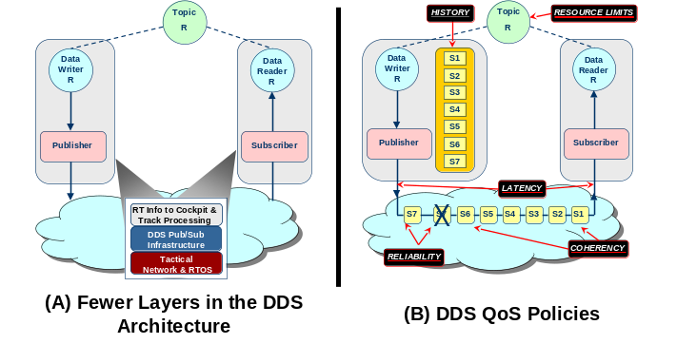
Figure 2: Optimizations and QoS Capabilities of DDS
Figures 2 and 3 show DDS capabilities that make it better suited as the basis of DRE information management than other standard middleware platforms. Figure 2(A) shows that DDS has fewer layers in its architecture than conventional SOA standards, such as CORBA, .NET, and J2EE, which significantly reducing latency and jitter, as shown in Section 4. Figure 2(B) shows that DDS supports many QoS properties, such as
- The lifetime of each data sample, i.e., is it destroyed after being sent, kept available during the publisher’s lifetime, or remain for a specified duration after the publisher shuts down.
- The degree and scope of coherency for information updates, i.e., whether a group of updates can be received as a unit and in the order in which they were sent.
- The frequency of information updates, i.e., the rate at which updated values are sent and/or received.
- The maximum latency of data delivery, i.e., a bound on the acceptable interval between the time data is sent and received
- The priority of data delivery, i.e., the priority used by the underlying transport to deliver the data.
- The reliability of data delivery, i.e., whether missed deliveries will be retried.
- How to arbitrate simultaneous modifications to shared data by multiple writers, i.e., to determine which modification to apply.
- Mechanisms and parameters to determine liveliness, i.e., whether data readers and data writers are still active or not.
- Parameters for filtering by data receivers, i.e., predicates which determine which data values are accepted or rejected.
- The duration of data validity, i.e., the specification of an expiration time for data to avoid delivering “stale” data.
- The depth of the ‘history’ included in updates, i.e., how many prior updates will be available at any time, e.g., ‘only the most recent update,’ ‘the last n updates,’ or ‘all prior updates’.
These parameters can be configured at various levels of granularity (i.e., topics, publishers, data writers, subscribers, and data readers), thereby allowing application developers to construct customized contracts based on the specific QoS requirements of individual entities. Since the identity of publishers and subscribers are unknown to each other, the DDS DCPS middleware is responsible for determining whether QoS parameters offered by a publisher are compatible with those required by a subscriber, only allowing data distribution when compatibility is satisfied.
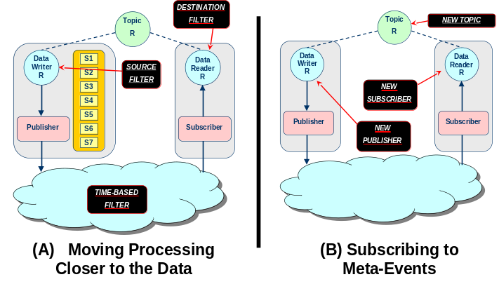
Figure 3: Filtering and Meta-event Capabilities of DDS
Figure 3(A) shows how DDS can migrate processing closer to the data source, which reduces bandwidth in resource-constrained network links. Figure 3(B) shows how DDS enables clients to subscribe to meta-events that they can use to detect dynamic changes in network topology, membership, and QoS levels. This mechanism helps DRE information management systems adapt to environments that are continuously changing.

Alternative DDS Implementations
The DDS specification defines only policies and interfaces between participants. To maximize the freedom of DDS providers, the specification intentionally does not address how to implement the services or manage DDS resources internally. Naturally, the particular communication models, distribution architectures, and implementation techniques used by DDS providers have a significant impact on application behaviour and QoS, i.e., different choices affect the suitability of different DDS implementations and configurations for different classes of DRE information management applications.
Table 1: Supported DDS Communication Models
DDS Impl | Unicast | Multicast | Broadcast
DDS1 | Yes (default) | Yes | No
DDS2 | No | Yes | Yes (default)
DDS3 | Yes (default) | No | No
The DDS implementations we evaluated for the Pollux project did not all support the same communication models. As shown in Table 1, DDS1 supports unicast and multicast, DDS2 supports multicast and broadcast, whereas DDS3 only supports unicast. We also found the three most popular DDS implementations have different architectural designs, as described in the remainder of this section.

Federated Architecture
The federated DDS architecture shown in Figure 4 uses a separate daemon process for each network interface. This daemon must be started on each node before domain participants can communicate remotely. Once started, it communicates with daemons running on other nodes and establishes data channels based on reliability requirements (e.g., reliable or best effort) and transport addresses (e.g., unicast or multicast). Each channel handles the communication and QoS for all the participants requiring its particular properties. Using a daemon process decouples the applications (which run in a separate user process) from configuration- and communication-related details. For example, the daemon process can use a configuration file to store common system parameters shared by communication endpoints associated with a network interface, so that changing the configuration does not affect application code or processing.
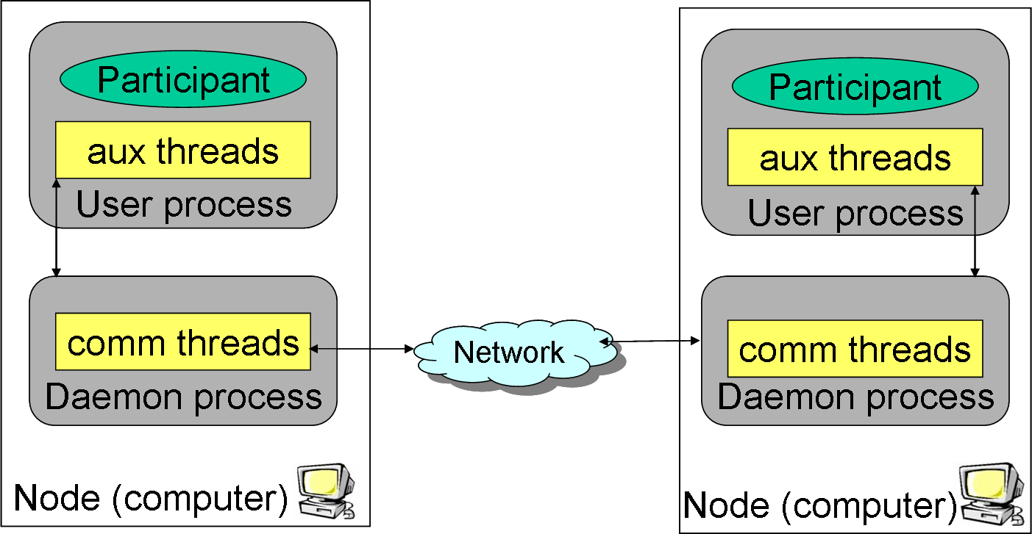

Figure 4: Federated DDS Architecture
In general, the advantages of a federated architecture are that applications can achieve higher scalability to larger number of DDS participants on the same node, e.g., by bundling messages that originate from different DDS participants. Moreover, using a separate daemon process to mediate access to the network can enable more orchestrated policies and prioritization of messages.
A disadvantage of this approach, however, is that it introduces an extra configuration step—and possibly another point of failure. Moreover, applications must cross extra process boundaries to communicate, which can increase latency and jitter.

Decentralized Architecture
The decentralized DDS architecture shown in Figure 5 places the communication- and configuration-related capabilities into the same user process as the application itself. These capabilities execute in separate threads (rather than in a separate daemon process) that the DCPS middleware library uses to handle communication, reliability, and QoS.
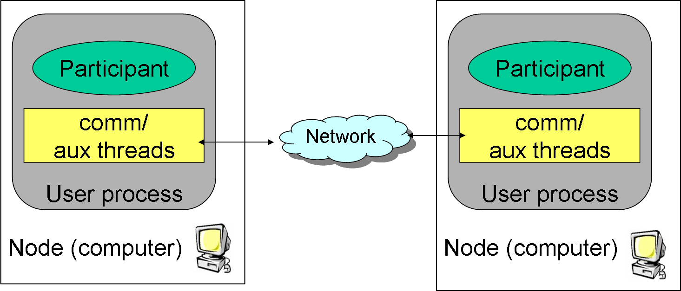

Figure 5: Decentralized DDS Architecture
The advantage of a decentralized architecture is that each application is self-contained, without the need for a separate daemon. As a result, there is less latency and jitter overhead, as well as one less configuration and failure point. A disadvantage, however, is that application developers may need to specify extra configuration details, such as. This architecture also makes it hard to buffer/optimize data sent to/from multiple DDS applications on a node, which loses some of the scalability benefits provided by the federated architecture described in Section 2.2.1.

Centralized Architecture
The centralized architecture shown in Figure 6 uses a single daemon server running on a designated node to store the information needed to initialize connections between different DDS participants in a domain.
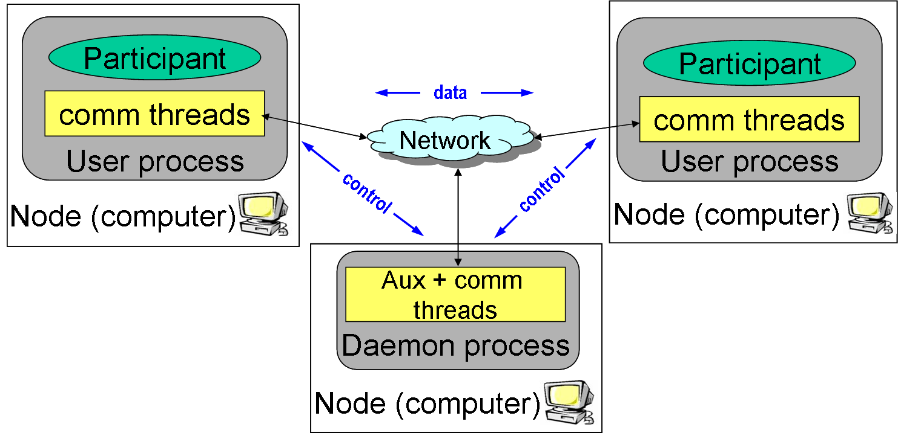

Figure 6: Centralized DDS Architecture
The advantage of the centralized approach is its simplicity of implementation and configuration since all control information resides in a single location. The disadvantage, of course, is that the daemon is a single point of failure, as well as a potential performance bottleneck in a highly loaded system.
The remainder of this paper investigates how the architecture differences described above can affect the performance experienced by DRE information management applications.

Methodology for Pub/Sub Platform Evaluation
This section describes our methodology for evaluating various pub/sub platforms to determine empirically how well they support various classes of DRE information management applications, including …

Evaluated Pub/Sub Platforms
In our evaluations, we focused on comparing the performance of the C++ implementations of DDS shown in Table 2 against each other.
Table 2: DDS Versions Used in Experiments
DDS Impl | Version | DDS Distribution Architecture
DDS1 | ? | Decentralized Architecture
DDS2 | ? | Federated Architecture
DDS3 | ? | Centralized Architecture

We also compared these three DDS implementations against the three other pub/sub middleware platforms shown in Table 3.
Table 3: Other Pub/Sub Platforms Used in Experiments
Platform | Version | Summary
CORBA Notification Service | TAO 1.x | ?
GSOAP | ? | ?
JMS | ? | ?
We compared the performance of these pub/sub mechanisms by using the following metrics:
- Latency, which is defined as the roundtrip time between the sending of a message and reception of an acknowledgment from the subscriber. In our test, the roundtrip latency is calculated as the average value of 10,000 round trip measurement.
- Jitter, which is the standard deviation value to measure the variation of the latency.
- Throughput, which is defined as the total number of bytes that the subscribers can receive at a unit time in different 1-to-n publisher/subscriber configurations, i.e., 1-to-4, 1-to-8, and 1-to-12.
We also compared the performance of the DDS listener-based and waitset-based subscriber notification mechanisms. Finally, we conducted qualitative evaluations of DDS portability and configuration mechanisms.

Benchmarking Environment

Hardware Testbed and Software Infrastructure
The computing nodes we used to run our experiments are hosted on ISISLab [19], which is a testbed of computer systems and network switches that can be arranged in many configurations. ISISLab consists of 6 Cisco 3750G-24TS switches, 1 Cisco 3750G-48TS switch, 4 IBM Blade Centers each consisting of 14 blades (for a total of 56 blades), 4 gigabit network IO modules and 1 management modules. Each blade has a two 2.8 GHz Xeon CPUs, 1GB of ram, 40GB HDD, and 4Gbps network interfaces.
In our test, we used up to 14 nodes (1 pub, 12 subs, and a centralized server in the case of DDS3). Each blade ran Fedora Core 4 Linux, version 2.6.16-1.2108_FC4smp. The DDS applications were run in the Linux real-time scheduling class to minimize extraneous sources of memory, CPU, and network load.

The DDS Benchmark Environment (DBE)
To facilitate the growth of our tests both in variety and complexity, we created the DDS Benchmarking Environment (DBE), which is an open-source framework for automating our DDS testing. The DBE consists of
- A directory structure to organize scripts, configuration files, test ids, and test results
- A hierarchy of Perl scripts to automate test setup and execution
- A tool for automated graph generation
- A shared library for gathering results and calculating statistics
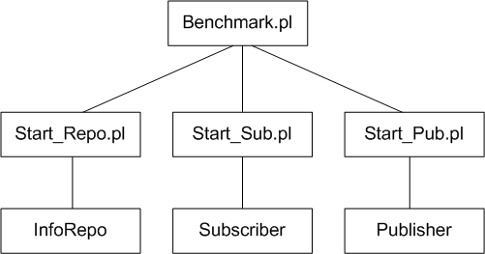
Figure 7: DDS Benchmarking Environment Architecture
The DBE has three levels of execution, as shown in Figure 7. This multi-tiered design enhances flexibility, performance, and portability while incurring low overhead. Each level of execution has a specific purpose, i.e., the top level is the user interface, the second level manipulates the node itself, and the bottom level is comprised of the actual executables (e.g., publishers and subscribers for each DDS implementation). DBE is also implemented carefully to maximize resource usage by the actual test executables rather than the DBE scripts. For example, if Ethernet saturation is reached in our testing, it is due to DDS topic data transmission and not to the DBE test artifacts.

Empirical Results
This section analyzes the results of benchmarks conducted using DBE in ISISlab. We first evaluate 1-to-1 roundtrip latency performance of DDS pub/sub implementations and compare them with the performance of non-DDS pub/sub implementations. We then demonstrate and analyze the results of 1-to-n scalability throughput tests for each DDS implementations, where n is 4, 8, and 12. All graphs of empirical results use logarithmic axes since the latency/throughput of some pub/sub implementations cover such a large range of values that linear axes are unreadable as payload size increases.

Latency and Jitter results
Benchmark design. Latency is an important measurement to evaluate DRE information management performance. Our test code measures roundtrip latency for each pub/sub middleware platform described in Section 3.1. We ran the tests on both simple and complex data types to see how well each platform handles marshaling/de-marshaling overhead introduced for complex data types. The IDL structure for the simple and complex data type is shown below.
// Simple Sequence Type
Struct data { long index; sequence<octet> data; }

// Complex Sequence Type
struct Inner { string info; long index; };
typedef sequence<Inner> InnerSeq;
struct Outer {
long length; InnerSeq nested_member;
};
typedef sequence<Outer> ComplexSeq;
The publisher writes a simple/complex data sequence of a certain payload size on a particular topic. When the subscriber receives the topic data it sends a 4-byte acknowledgement in response. The payload sequence length for both simple and complex data ranges from 4 to 16,384 by powers of 2.
The publisher test code measures latency by timestamping the execution of the data transmission and subtracting that from the timestamp value when its receives the ack from the subscriber. The goal of this test is to evaluate how fast data gets transferred from one pub/sub node to another at different payload sizes. To eliminate factors, other than differences among the middleware implementations that affect latency/jitter, we tested a single publisher sending to a single subscriber running in separate processes on the same node. Since each node has two CPUs the publisher and subscriber can execute in parallel.
Results. Figures 8 and 9 show the latency/jitter results for all pub/sub platforms using the simple data type. These figures show how the latency/jitter of all three DDS implementations is low compared to conventional pub/sub middleware. In particular, DDS1 has extremely low latency and jitter compared with the other pub/sub mechanisms.
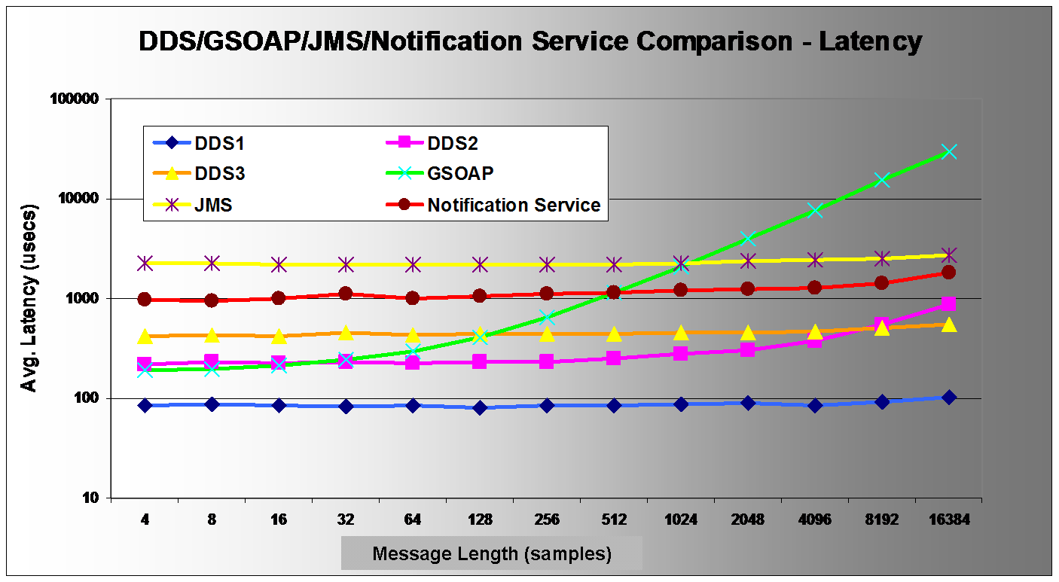
Figure 8: Simple Data Type Jitter

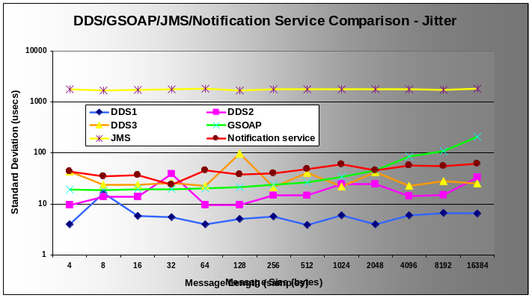

Figure 9: Simple Data Type Jitter
Figures 10 and 11 show the latency and jitter results for all pub/sub platforms using the complex data type. These figures show that although latency/jitter increases faster as data size increase the non-DDS middleware still trails DDS by a large margin.
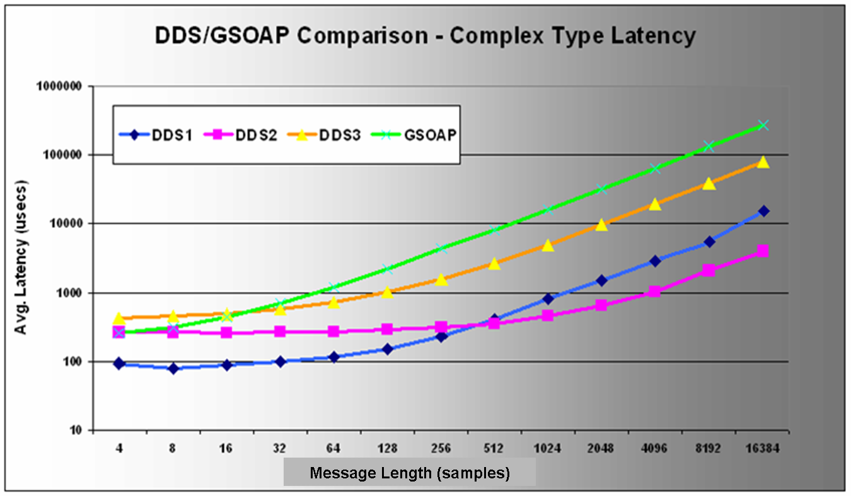
Figure 10: Complex Data Type Jitter

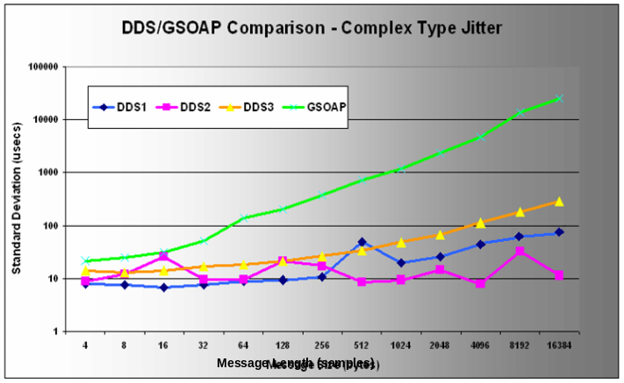

Figure 11: Complex Data Type Jitter
Analysis: There are several explanations for the results in Figures 10 and 11. As discussed in Section 2.1, DDS has fewer layers than other standard pub/sub platforms, so it incurs much lower latency and jitter. The low latency of DDS1 stems largely from its mature implementation, as well as its architecture shown in Figure 5, in which publishers communicate to subscribers without going through a separate daemon process. In contrast, DDS2’s federated architecture involves an extra hop through a pair of daemon processes (one on the publisher and one on the subscriber), which helps explain why its latency is higher than DDS1’s when sending small simple data types.
These figures also indicate that sending complex data type incurs more (de)marshaling overhead for all pub/sub implementations, particularly as data size increases. Interesting, the latency increase rate of GSOAP is nearly linear as its data size increases, i.e. if the data size doubles, the latency nearly doubles as well. GSOAP’s poor performance with large payloads stems largely from its XML representation for sequences, which (de)marshals each element of a sequence using a verbose text-based format rather than (de)marshaling the sequence as a whole like DDS and CORBA.

Throughput Results
Benchmark design. Throughput is another important performance metric for DRE information management systems. The primary goals of our throughput tests, therefore, were to measure how well each DDS implementation handles scalability, how different communication models (e.g. unicast, multicast, and broadcast) compare in performance, and how synchronous (wait-based) and asynchronous (listener-based) compare. To maximize scalability in our throughput tests, the publisher and subscriber(s) reside in different processes on different hosts.
In the remainder of this subsection we first evaluate the performance results of individual DDS implementations as we vary the communication models they support, as per the constraints outlined in Table 1. We then compare the multicast performance of DDS1 and DDS2, as well as the unicast performance of DDS1 and DDS3, which are the only common points of evaluation at this point.
[Guys, please add a paragraph here that explains how each figure contains a box that summarizes what DDS QoS policies are used for the benchmark. Make sure to also emphasize that we are using the “best effort” QoS policy for throughput and explain our rationale for doing this (I recommend that it have something to do with the fact that we are focusing on DRE information management, which may preclude the overhead of retransmitting lost data samples, etc.]

DDS1 Unicast/Multicast
Results. Figures 12 and 13 show the results of our scalability tests for DDS1 unicast/multicast with 1 publisher and multiple subscribers. These figures show that unicast performance degrades drastically when scaling up, whereas multicast scales up without affecting throughput significantly.
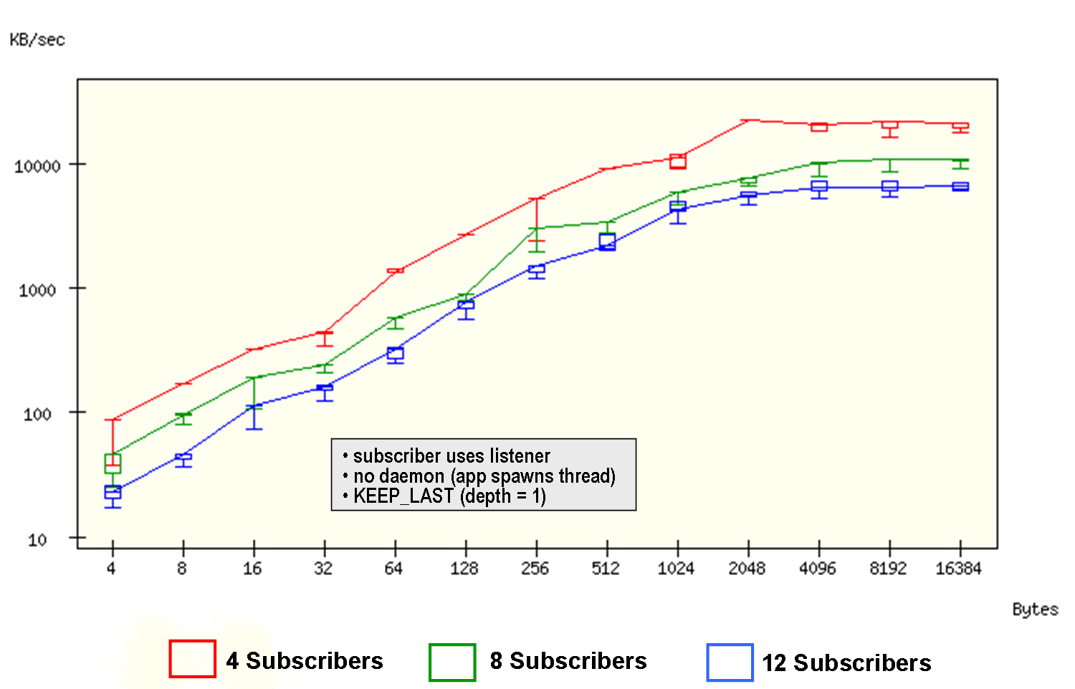

Figure 12: DDS1 Unicast Scalability Throughput

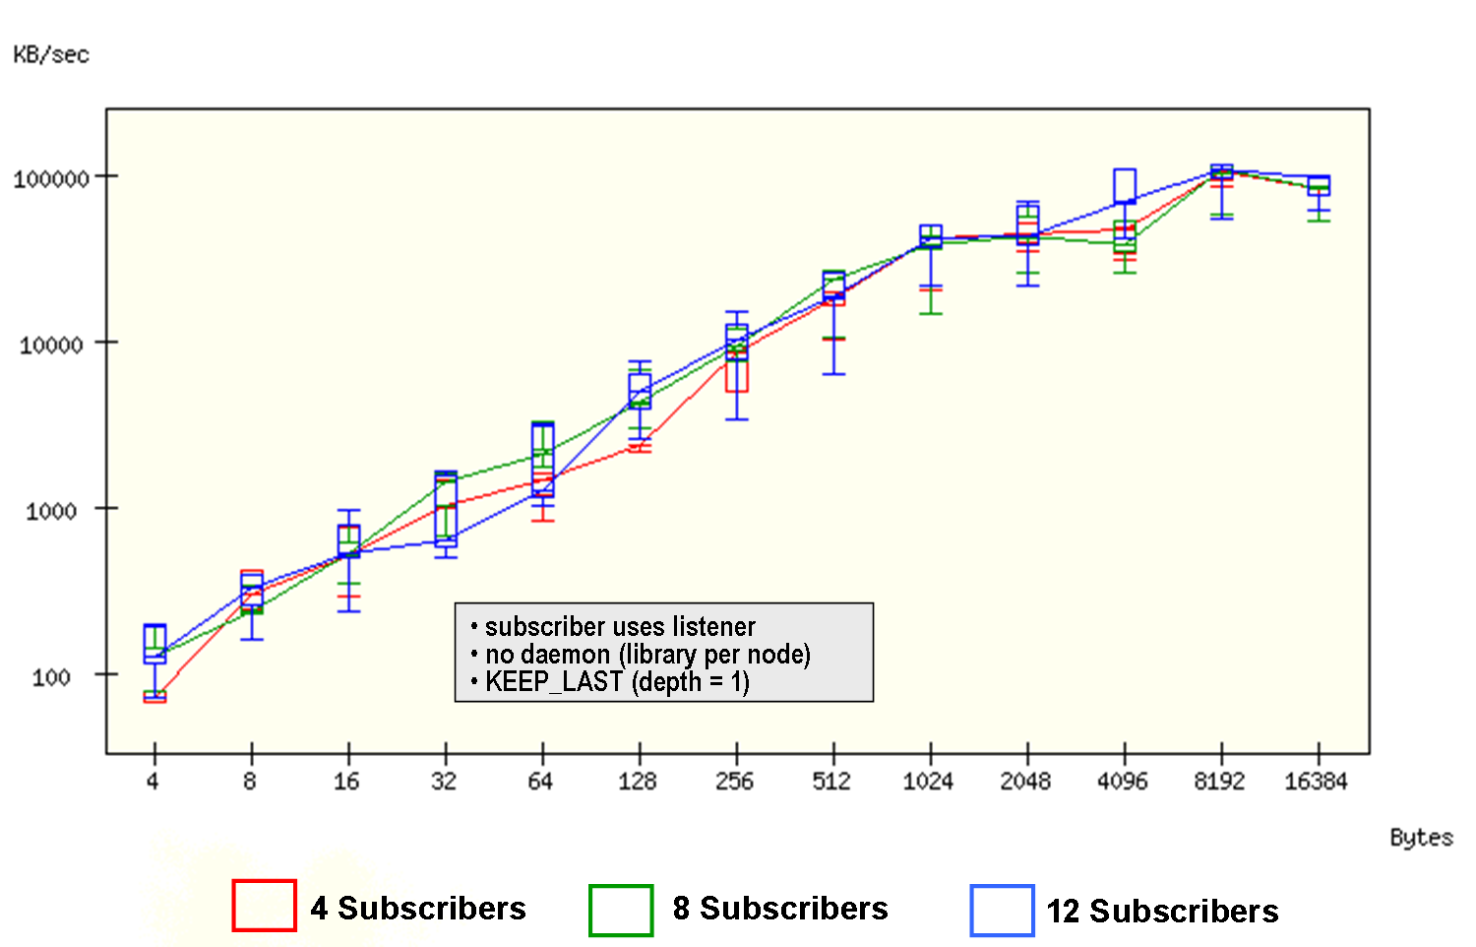

Figure 13: DDS1 Multicast Scalability Throughput

Figures 14 and 15 compare unicast and multicast of DDS1 for multiple subscribers. We can see that multicast performs better than unicast and the difference becomes greater in 1 pub to 12 subs than in 1 pub to 4 subs.
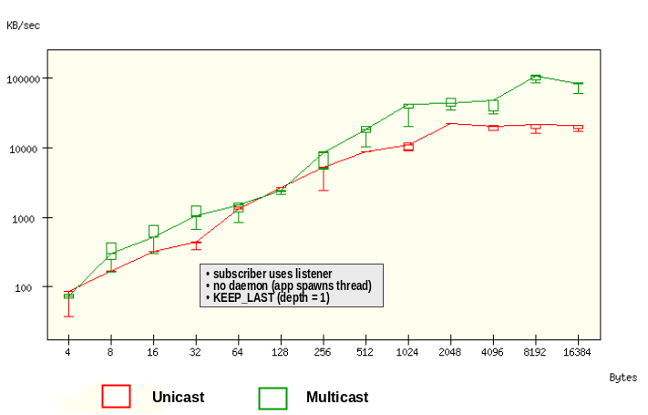

Figure 14: 1-4 DDS1 Unicast vs. DDS1 Multicast

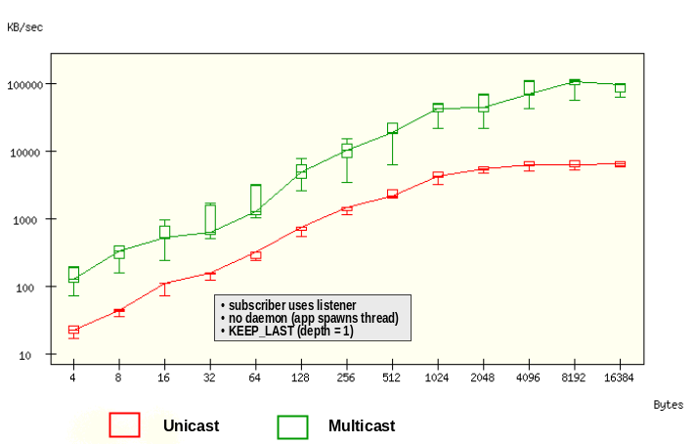

Figure 15: 1-12 DDS1 Unicast vs. DDS1 Multicast

Analysis. Figure 12 indicates that the overhead of unicast leads to performance degradation as the number of subscribers increases since the middleware sends a copy to each subscribe. Figure 13 indicates how multicast improves scalability since only one copy of the data is delivered regardless of how many recipients in the domain subscribe. Figure 14 and 15 demonstrates the performance edge of multicast over unicast and indicates that the more subscribers we deploy the more benefit we can obtain from using multicast.

DDS2 Broadcast/Multicast
Results. Figure 16 shows the scalability test results for DDS2 broadcast with 1 publisher and multiple subscribers (i.e., 4, 8, and 12). This figure shows that broadcast scales well as the number of subscribers increases. Figures 17 and 18 compare DDS2 broadcast and multicast performance. This figure shows that multicast generally performs better than broadcast. Moreover, as the number of subscribers increases, this performance difference also increases.
Analysis. To be added.

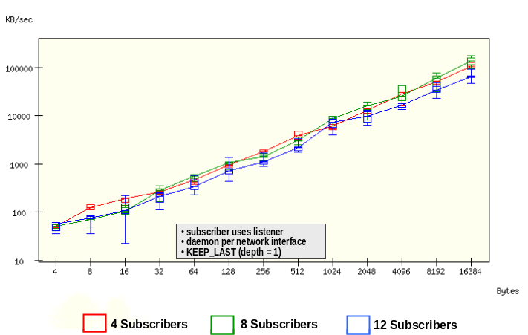

Figure 16: DDS2 Broadcast Scalability Throughput

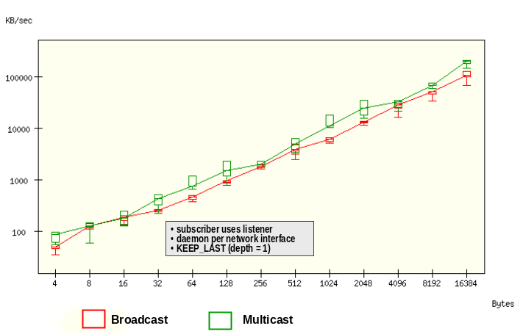

Figure 17: 1-4 DDS2 Broadcast vs. DDS2 Multicast

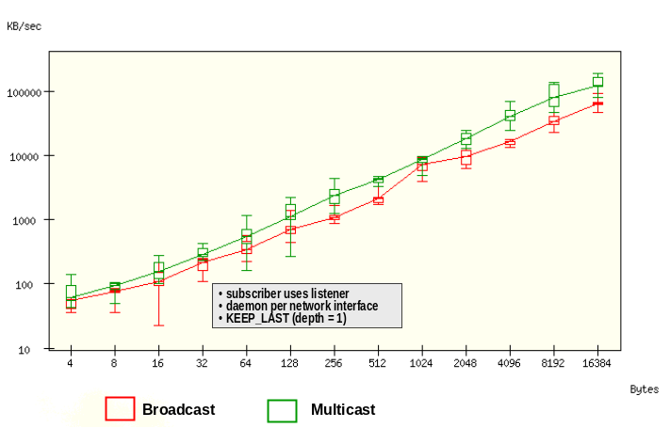

Figure 18: 1-12 DDS2 Broadcast vs. DDS2 Multicast

Comparing DDS Implementation Performance
Results. Figure 19 shows multicast performance comparison of DDS1 and DDS2 with 1 publisher and 8 subscribers. Since DDS3 does not currently support multicast we omit it from the comparison. Figure 20 shows unicast performance comparison of DDS1 and DDS3. Since DDS2 does not support unicast we also omit it from this comparison.
Analysis. Figures 19 and 20 indicate that DDS1 outperforms DDS2 for smaller data sizes. As the size of the payloads increase, however, DDS2 performs better. It appears that the difference in the results stems from the different distribution architectures used to implement DDS1 and DDS2, which are the decentralized and federated architectures, respectively.

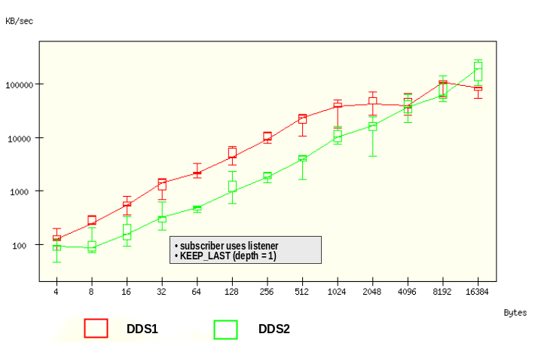

Figure 19: 1-8 DDS1 Multicast vs. DDS2 Multicast

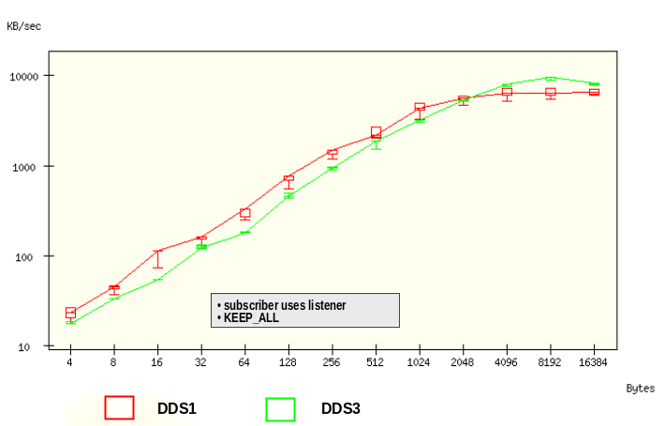

Figure 20: 1-8 DDS1 Unicast vs. DDS3 Unicast

Comparing Wait-based vs Listener-based Notification Mechanisms
Benchmark design.
Results.. Figure 21 shows the performance comparisons of listener-based and wait-based notification mechanisms. This figure shows that for DDS1, listener-based notification outperforms wait-based notification, and for DDS2, there is no consistent difference between the two.
Analysis. (To be added)
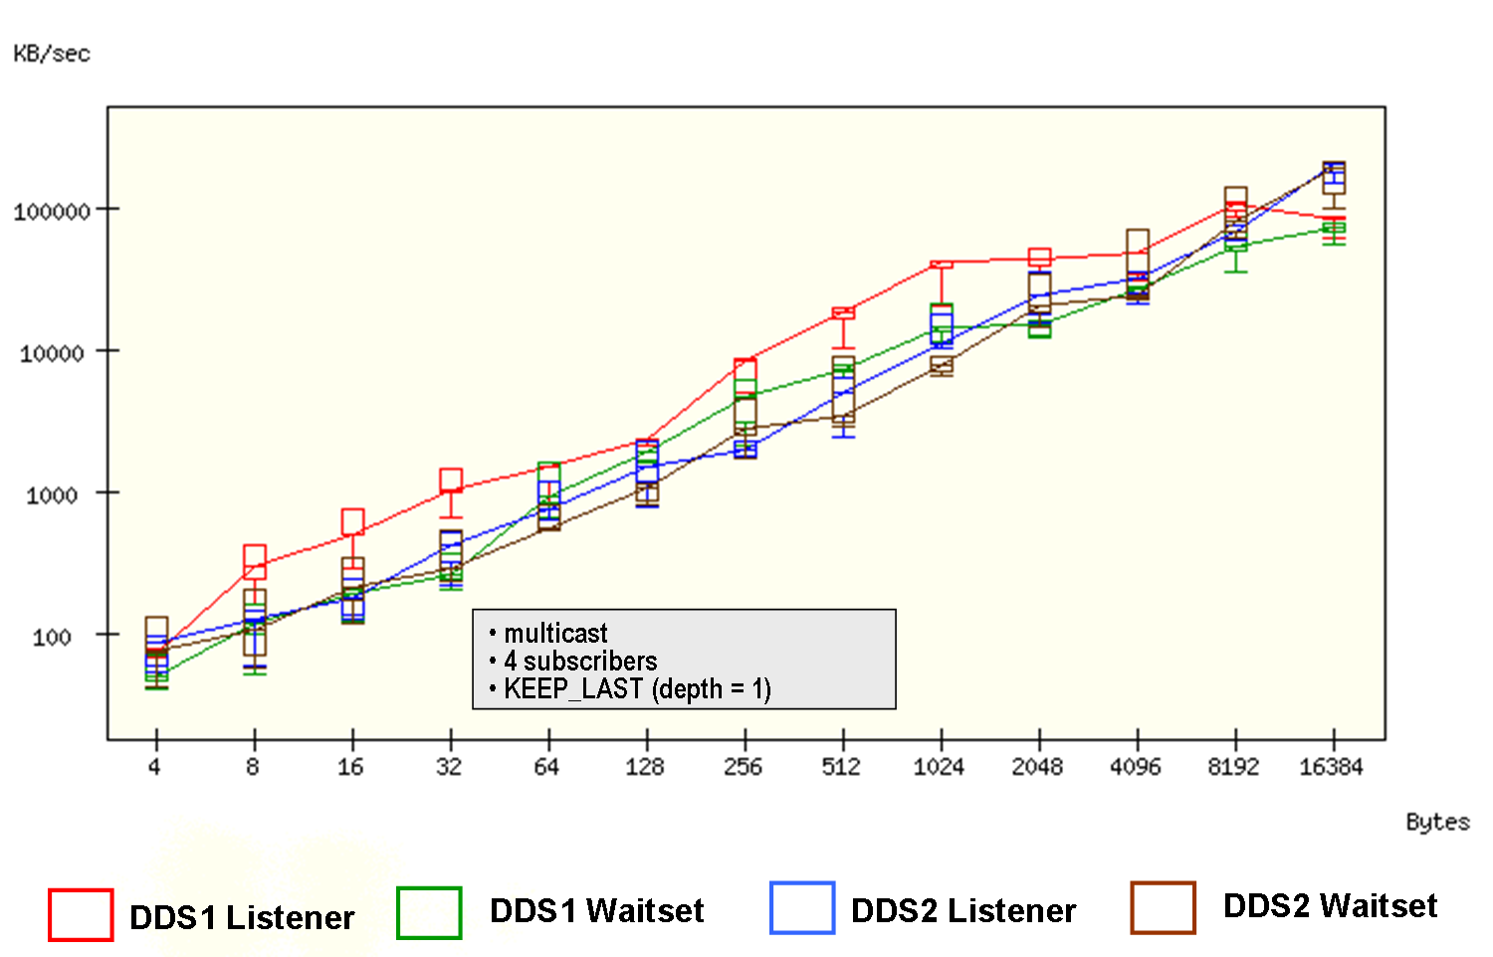

Figure 21: Listener-based vs. Wait-based

Key Challenges and Lessons Learned
This section describes the challenges we encountered when conducting the experiments presented in Section 4 and summarizes the lessons learned from our efforts.

Resolving DBE Design and Execution Challenges
When designing DBE and running our benchmark experiments, we encountered a number of challenges. Below, we summarize these challenges and how we addressed them.
Challenge1: Synchronizing Distributed Clocks
Problem: It is hard to precisely synchronize clocks between applications running on blades distributed throughout ISISLab. Even when using the Network Time Protocol (NTP) we still experienced differences in time that ranged from x to y, and we have to constantly repeat the synchronization routines to make sure that the time in different nodes are in sync. We therefore needed to avoid relying on synchronized clocks to measure latency, jitter, and throughput.
Solution: For our latency experiments, we simply have the subscriber send a minimal reply to the publisher, and use on the clock on the publisher side to calculate the roundtrip time. For throughput, we use the subscriber’s clock to measure the time required to receive a designated number of samples. Both methods provide us with common reference points and minimize timing errors through the usage of effective latency and throughput calculations based on a single clock.
Challenge2: Automating Test Execution
Problem: Achieving good coverage of a test space where parameters can vary in several orthogonal dimensions leads to a combinatorial explosion of test types and configurations. Manually running tests for each configuration, for each middleware implementation on each node is tedious, error-prone and extremely time-consuming. The task of managing and organizing test results also grows exponentially along with the number of distinct test configuration combinations.
Solution: The DBE, described in Section 3.2.2, grew out of our efforts to manage the large number of tests and the associated volume of result data. Our efforts to streamline test creation, execution and analysis are ongoing, and include work on several fronts – a hierarchy of scripts, several types of configuration files, and test code refactoring.
Challenge3: Handling Packet Loss
Problem: Since our DDS implementations support the UDP transport, it is possible for packets to be dropped, both at the publisher and subscriber side, so we need to be sure that the subscribers get the designated number of samples in spite of packet loss.
Solution: We let publishers oversend an appropriate amount of extra data to ensure that the subscribers will successfully receive enough samples.
Challenge4: Ensuring Steady Communication State
Problem: We need to make sure our benchmark applications are in a steady state when statistical data is being collected.
Solution: We send primer samples to “warm up” the applications before actually measuring the data. This warmup period allows time for possible discovery activity related to other subscribers to finish, and for any other first-time actions, on-demand actions, or lazy evaluations to be completed, so that their extra overhead does affect the statistics calculations.

Summary of Lessons Learned
Based on the results and our experience of developing DBE and running the DDS experiments we learned the following lessons:
- DDS Performs significantly better than other pub/sub implementations – Figure 7 in section 4.1 shows that even the slowest DDS was around 2 times faster than non-DDS pub/sub services. This performance margin is made possible partly by the fact that DDS decouples the information intent from information exchange. In particular, an XML-based pub/sub mechanism such as SOAP is optimized for transmitting strings, whereas the data types we used for testing were sequences. GSOAP’s poor performance with large payloads is due to the fact that its design requires it to marshal/de-marshal each element of a sequence, which may be a small as a single byte, while DDS implementations can send and receive such data types as blocks.
- DDS scales better to larger payloads, especially for simple data types – Figure 7 and Figure 8 from Section 4.1 shows that DDS pub/sub middleware scales better for larger payloads compared to non-DDS pub/sub middleware.
- Individual DDS implementations are optimized for different use cases – Figures 8 and 16 indicate that DDS1 is optimized for smaller payload sizes compared to DDS2. As payload size increases, especially for the complex date type measured in Figure 8, DDS2 catches up and surpasses DDS1 in performance. Similarly, Figures 9, 10 and 13 indicate that DDS2’s performance stays more constant than that of DDS1 as the number of subscribers increases.
- It is hard to make apples-to-apples comparisons of DDS implementation. The difference falls into the following three categories:
- No common transport protocol, e.g., the DDS implementations that we investigated share no common application protocol. DDS1 uses RTPS like protocol on top of UDP. DDS2 will add RTPS support soon but not yet, DDS3 simply implements on top of raw TCP and UDP. Note that this lack of a common transport protocol is not a shortcoming of the implementations, but entirely due to the fact that a standard transport protocol had not been adopted when the most recent releases of these implementations were made.
- No universal support for unicast/broadcast/multicast. Table 1 shows the different mechanisms supported by each DDS implementations, from which we can see DDS3 does not support any point to multi-points transport, thus making it hard to scale as number of subscribers increase.
- DDS applications are not yet portable, which is partially due to fact that the specification is still evolving and vendors use proprietary techniques to fill the gaps. A portability wrapper façade would be a great help to any DDS application developer, and a huge help to our efforts in writing and running large numbers of benchmark tests.
- Substantial tuning of policies and options are required or suggested by vendors to optimize performance, which adds difficulty to designing universal benchmark configurations, as well as to the learning curve of any application developer.
- Broadcast can be a double-edged sword – Using broadcast can significantly increase performance but it also has the potential to exhaust the network router bandwidth.

Related Work
As an emerging technology for Global Information Grid and data-critical real-time systems, DDS in particular, and publish/subscribe architecture in general, has attracted a considerably increasing number of research efforts such as COBEA [20], Siena [12) and commercial products and standards (such as JMS [10], WS_NOTIFICATION [13], the CORBA Event and Notification services [17]). This Section describes the growing body of work related to our effort.
Open Architecture Benchmark. Open Architecture Benchmark (OAB) is a DDS benchmark effort along with Open Architecture Computing Environment, an open architecture initiated by the US Navy to facilitate future combat system software development. Joint efforts have been conducted in OAB to evaluate DDS products, in particular RTI’s NDDS and THALES DDS, and to understand the ability of these DDS products to support bounded latencies and sustained throughput required by combat system applications [8].
CORBA Pub/Sub Services. OMG has specified a Notifi-cation Service [21], which is a superset of the CORBA Event Service that adds interfaces for event filtering, configurable event delivery semantics (e.g., at least once or at most once), security, event channel federations, and event delivery QoS. The patterns and techniques used in the implementation of TAO’s Real-time Event Service can be used to improve the performance and predictability of Notification Service implementations. A Notification Service for TAO [22] has been implemented and used it to validate the feasibility of building a reusable framework that factors out common code for TAO’s Notification Service, its standard CORBA Event Service implementation, and its Real-time Event Service.
PADRES: The Publish/subscribe Applied to Distributed Resource Scheduling (PADRES) is a novel distributed, content-based publish/subscribe messaging system. A PADRES system consists of a set of brokers connected by overlay network. Each broker employs a rule-based engine to route and match publish/subscribe messages, and is used for composite event detection.

More

Concluding Remarks
This paper describes and evaluates the architectures of three popular implementations of the OMG Data Distribution Service (DDS). It then presents the DDS Benchmarking Environment (DBE) and uses DBE to compare the performance of these DDS implementations, as well as non-DDS pub/sub platforms. Our results show that

As part of the ongoing Pollux project, we will continue to evaluate other interesting features of DDS needed by large-scale DRE information management systems. Our future work will include (1) tailoring benchmarks to explore key classes of applications in DRE information management systems, (2) devising generators that can emulate various workloads and use cases, (3) including a wider range of QoS configurations, e.g. durability, reliable vs. best effort, integration of durability, reliability and history depth, (4) designs for migrating processing toward data sources, (5) measuring participant discovery time for various entities, (6) identifying scenarios that distinguish performance of QoS policies and features e.g. collocation applications, and (7) evaluating the suitability of DDS in heterogeneous dynamic environments, e.g., mobile ad hoc networks, where system resources are limited and dynamic configuration changes are common.
Acknowledgements
We would like to thank Real-Time Innovations (RTI), Prism Technologies (PT), and Object Computing Inc. (OCI), particularly Dr. Gerardo Pardo-Castellote, Ms Gong Ke from RTI, Dr. Hans van’t Hag from PrismTech, and Yan Dan and Steve Harris from OCI, for their extensive help performing the experiments reported in this paper.

References
- Gerardo Pardo-Castellote, Bert Farabaugh, Rick Warren, “An introduction to DDS and Data-Centric Communications,” www.rti.com/resources.html.
- Douglas C. Schmidt and Carlos O'Ryan, “Patterns and Performance of Distributed Real-time and Embedded Publisher/Subscriber Architectures,” Journal of Systems and Software, Special Issue on Software Architecture -- Engineering Quality Attributes, edited by Jan Bosch and Lars Lundberg, October 2002.
- Chris Gill, Jeanna M. Gossett, David Corman, Joseph P. Loyall, Richard E. Schantz, Michael Atighetchi, and Douglas C. Schmidt, “Integrated Adaptive QoS Management in Middleware: An Empirical Case Study,” Proceedings of the 10th Real-time Technology and Application Symposium, May 25-28, 2004, Toronto, CA
- Gerardo Pardo-Castellote, “DDS Spec Outfits Publish-Subscribe Technology for GIG,” COTS Journal, April 2005
- Gerardo Pardo-Castellote, “OMG Data Distribution Service: Real-Time Publish/Subscribe Becomes a Standard,” www.rti.com/docs/reprint_rti.pdf.
- OMG, “Data Distribution Service for Real-Time Systems Specification,” www.omg.org/docs/formal/04-12-02.pdf
- DOC DDS Benchmark Project Site, www.dre.vanderbilt.edu/DDS.
- Bruce McCormick, Leslie Madden, “Open Architecture Benchmark,” Real-Time Embedded System Work Shop 2005, www.omg.org/news/meetings/workshops/RT_2005/03-3_McCormick-Madden.pdf.
- Arvind S. Krishna, Douglas C. Schmidt, Ray Klefstad, and Angelo Corsaro, “Real-time CORBA Middleware,” in Middleware for Communications, edited by Qusay Mahmoud, Wiley and Sons, New York, 2003
- Sun Microsystems, “J2EE 1.4 Tutorial,” java.sun.com/j2ee/1.4/docs/tutorial/doc/, December 2005
- Fox, G., Ho,A., Pallickara, S., Pierce, M., and Wu,W, “Grids for the GiG and Real Time Simulations,” Proceedings of Ninth IEEE International Symposium DS-RT 2005 on Distributed Simulation and Real Time Applications, 2005
- D.S.Rosenblum, A.L.Wolf, “A Design Framework for Internet-Scale Event Observation and Notification,” 6th European Software Engineering Conference. Lecture Notes in Computer Science 1301, Springer, Berlin, 1997, pages 344-360
- IBM, “Web Service Notification,” www-128.ibm.com/developerworks/library/specification/ws-notification.
- PrismTech, “Overview of OpenSplice Data Distribution Service,” www.prismtechnologies.com/section-item.asp?sid4=&sid3=252&sid2=10&sid=18&id=557.
- Real-Time Innovation, RTI Data Distribution Service, www.rti.com/products/data_distribution/index.htm.
- Real-Time Innovation, “Unmanned Georgia Tech Helicopter files with NDDS,”
controls.ae.gatech.edu/gtar/2000review/rtindds.pdf
- Pradeep Gore, Douglas C. Schmidt, Chris Gill, and Irfan Pyarali, “The Design and Performance of a Real-time Notification Service,” Proceedings of the 10th IEEE Real-time Technology and Application Symposium (RTAS '04), Toronto, CA, May 2004
- Nayef Abu-Ghazaleh, Michael J. Lewis, and Madhusudhan Govindaraju, “Differential Serialization for Optimized SOAP Performance,” Proceedings of HPDC-13: IEEE International Symposium on High Performance Distributed Computing, Honolulu, Hawaii, pp. 55-64, June 2004.
- DOC Group, DDS Benchmark Project, www.dre.vanderbilt.edu/DDS/html/testbed.html.
- C.Ma and J.Bacon “COBEA: A CORBA-Based Event Architecture,” In Proceedings of the 4rd Conference on Object-Oriented Technologies and Systems, USENIX, Apr.1998
- Object Management Group, “Notification Service Specification,” Object Management Group, OMG Document telecom/99-07-01 ed., July 1999
- P. Gore, R. K. Cytron, D. C. Schmidt, and C. O’Ryan, “Designing and Optimizing a Scalable CORBA Notification Service,” in Proceedings of the Workshop on Optimization of Middleware and Distributed Systems, (Snowbird, Utah), pp. 196–204, ACM SIGPLAN, June 2001

The Real-Time Publish Subscribe (RTPS) protocol was formally adopted by the OMG in June 2006 as the default transport protocol for DDS, but is not yet integrated into the DDS specification.

