Model Intelligence

Jules White and Douglas C. Schmidt
Department of Electrical Engineering and Computer Science
Vanderbilt University
Nashville, TN, USA

Andrey Nechypurenko and Egon Wuchner
Siemens Corporate Technology, SE6
Munich, Germany

Abstract
Model-Driven Engineering helps facilitate building solutions in many enterprise application domains through its use of high-level domain-specific abstractions and constraints. An important attribute of MDE approaches is their ability to check a solution for domain-specific requirements, such as security constraints, that are difficult to evaluate using traditional source-code focused development efforts. In many enterprise domains, however, finding a legitimate solution is the challenge and not merely checking solution correctness. For these domains, we propose that Model Intelligence, a mechanism for using the domain constraints to guide the modeler, is needed. This paper shows how existing constraint specification and checking practices, such as the Object Constraint Language, can be adapted and reasoned with by a modeling tool to guide users towards correct solutions using visual queues.

Keywords: Domain-specific Modeling, Model-Driven Engineering, Constraint Checking, Constraint Reasoning, Modeling Guidance

1. Introduction

Model-Driven Engineering (MDE) has emerged as a powerful approach to building complex enterprise systems. MDE allows developers to build solutions using abstractions, such as custom diagramming languages, tailored to their solution domain. For example, in the domain of deploying software to servers in a datacenter, developers can manipulate Visio-like diagrams showing how software components are mapped to individual hosts, as shown in Figure 1.
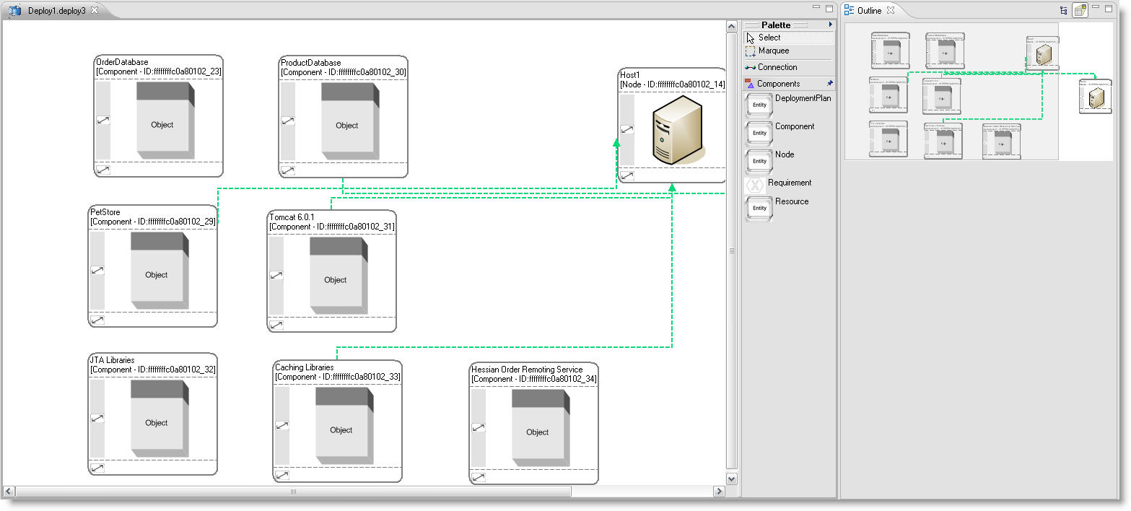
Figure 1. Deployment Model for a Datacenter

One major benefit that MDE approaches provide is that custom constraints for each domain can be captured and embedded into an MDE tool. These domain constraints are properties, such as the memory demands of a software component on a server, which cannot be easily checked by a compiler or other third-generation programming language tool. The domain constraints serve as a domain solution compiler that can significantly improve the confidence in the correctness of a solution for a domain. The most widely used constraint specification language is the Object Constraint Language (OCL).

Although MDE can improve solution correctness and catch previously hard to identify errors, in many domains, deriving the correct solution, not checking solution correctness, is the major challenge. For example, when deploying software components to servers in a datacenter, each component can have numerous functional constraints, such as requiring a specific set of other components to be co-hosted with it, and non-functional constraints, such as requiring a firewalled host, that make developing a deployment model hard. When faced with large enterprise models with 10s, 100s, or 1000s of model elements and multiple constraints per element, manual modeling building approaches do not scale.

Moreover, global constraints, such as requiring that no host’s allocation of components exceeds its available RAM, are typically in play, further complicating the deployment planning. Thus, although languages like OCL can be used to validate a solution, they still do not make finding the correct solution any easier. A developer must still manually construct models and invoke constraint checking to see if a mistake has been made.

There are two key properties of enterprise models that make building models challenging:

- Enterprise models are often large and may contain multiple views making it difficult or infeasible for a modeler to see all of the information required to make a complex modeling decision
- Constraints in enterprise systems often involve both functional and non-functional concerns that are scattered across multiple views or aspects of a model and are hard to solve manually
- Enterprise modeling solutions may need to satisfy complex global constraints or provide optimality, both of which require finding and evaluating a large number of potential solution models

Current model construction techniques are almost entirely manual processes. The difficulty of seeing an entire large enterprise model and the need to find and evaluate a large number of potential solutions makes enterprise modeling hard.

Ideally, when modeling the deployment of software components to servers in a datacenter, as a developer clicked on each individual software component to deploy it, the underlying tool infrastructure could use the domain constraints to derive the viable hosts for the component by checking OS, RAM, power consumption, and other host properties. To help alleviate the complexity of developing models in domains with intricate constraints and a desire for optimization, tool support is needed that can help guide developers towards correct solutions. We refer to mechanisms for guiding modelers towards correct solutions as Model Intelligence.

The remainder of this paper is organized as follows….

2 Limitations of Current Constraint Checking Approaches
To motivate the challenges of using existing constraint infrastructure, such as OCL, as a guidance mechanism, we will evaluate a simple constraint for deploying a software component to a server. For each component, the host that the component is deployed to should have the correct OS that the component is compiled for. This constraint can be captured in OCL as:

context:SoftwareComponent;
inv: self.hostingServer.OS = self.requiredOS;

After a SoftwareComponent has been deployed to a server, the above constraint checks that the host, stored in the hostingServer variable, has the OS required by the component. The challenge is that the constraint can only be used after a component is assigned to a server. As shown in Figure 2, the user’s modeling edit transitions the model into a new state. Only after the new state is entered, can the constraint checker be run to determine if the state is correct or not. Before entering the state, the user cannot be certain that the state that the model is being transitioned to is correct.
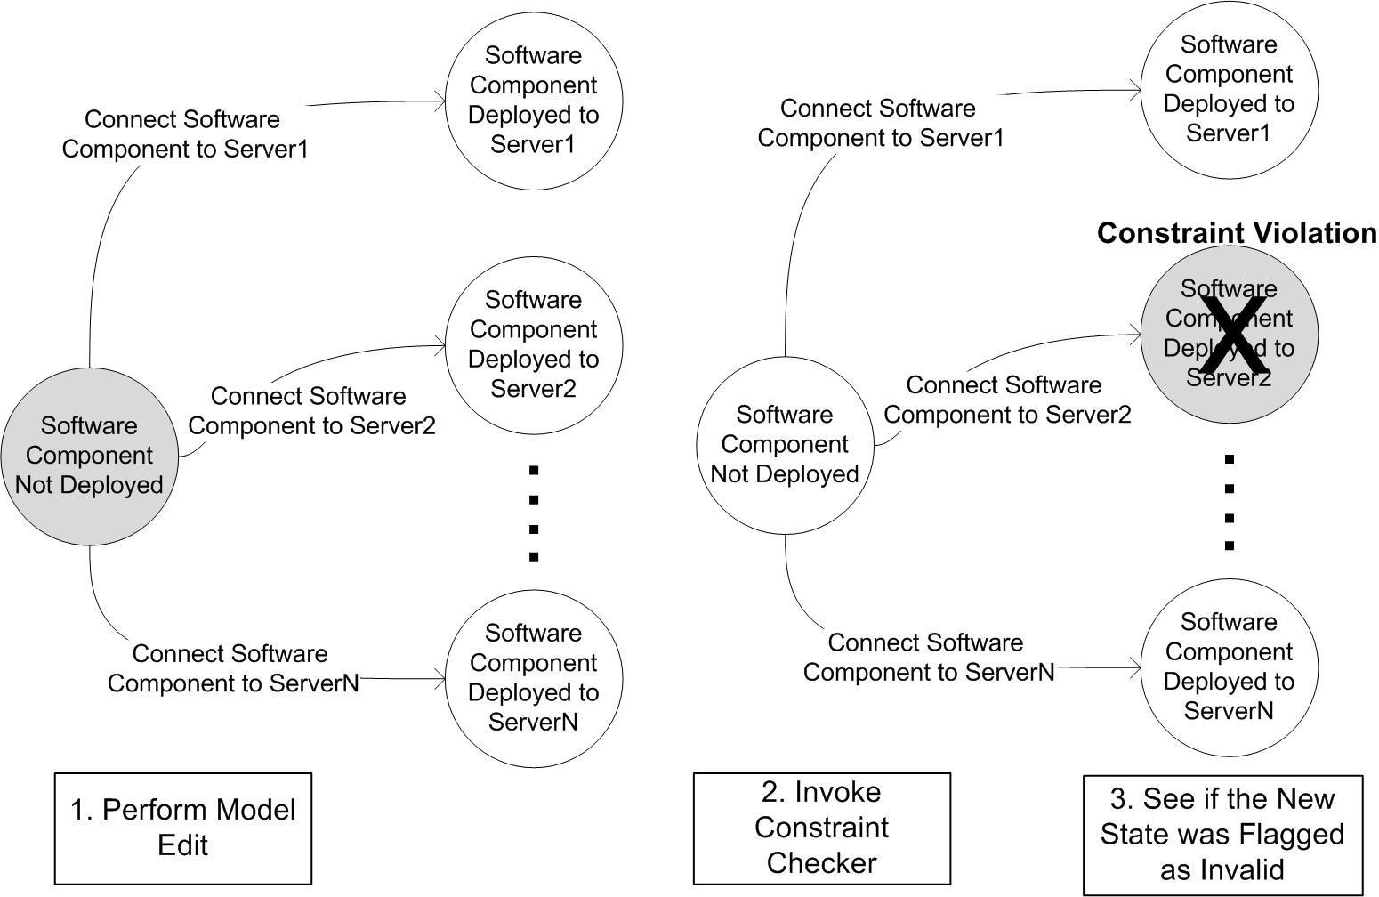

Figure 2. Model Editing and Constraint Checking

One potential way around this inability to check the constraint before the host is committed to the SoftwareComponent is to use OCL preconditions as guards on transitions. An OCL precondition is an expression that must hold true before an operation is executed. The chief problem of using OCL preconditions as guards is that they are designed to specify the correct behavior of an operation performed by the implementation of the model. Using an OCL precondition as a guard during modeling requires defining the constraint in terms of the operation performed by the modeling tool and not the model.

For example, the precondition that needs to be imposed to check for the correct OS is a constraint on an operation performed by the modeling tool (e.g., creating a connection) and not by the model. Thus, to define the OCL precondition, a developer must define the OCL constraint in terms of the modeling tool’s definition of the operation, which may not use the same terminology as the model. Furthermore, defining the constraint as a precondition on an operation performed by the modeling tool requires the developer to create a duplicate constraint to check if an existing model state is correct.

Without two constraints, one to check the correctness of the modeling tool action and one to check the correctness of an already constructed model state, it is impossible to both identify operation endpoints and ensure model consistency. Thus, the OCL precondition approach adds complexity by requiring the developer to maintain separate and not necessarily identical definitions of the constraint that can potentially drift out of sync. The precondition approach also couples the constraint to a single modeling platform since the precondition is defined in terms of the connection operation exposed by the tool and not the model.

3 Model Intelligence

In order to implement Model Intelligence, a modeling tool needs to be able to use a constraint to check a particular component / host combination before committing the change to the targetHost variable and without defining a separate precondition in terms of the modeling platform. Traditional mechanisms of specifying constraints associate a constraint with objects (e.g., SoftwareComponents) rather than the relationships between the objects (e.g., the deployment relationship between a SoftwareComponent and a Server). Thus, in order to determine the validity of a relationship between two objects, the relationship must be created and committed to the model so that the constraints on the two objects associated with the relationship can be checked.

The transitions in the state diagram from Figure 1 correspond to the creation of relationships between objects. It is the modification of the relationships between the objects that a tool needs to be able to use the domain constraints to check the correctness of in order to provide Model Intelligence. If constraints are associated with the relationships rather than the objects, a tool can use the constraints associated with the relationship as a guard on a transition.

3.1 Constraining Relationships

Relationships between objects are edges in the underlying object graph of a model. Each edge has a source and target object. Using this understanding of relationships, constraints can be created that specify the correctness of a relationship in terms of properties of the source and target elements. For example, the deployment of a SoftwareComponent to a Server is represented as a Deployment relationship. A constraint can very naturally be applied to a Deployment relationship and specified in terms of the properties of the source (i.e. a SoftwareComponent) and the target (i.e. a Server):

context:Deployment;
inv: source.requiredOS = target.OS;

A key property of associating constraints and specifying them in terms of the source and target of the relationship is that a constraint can be used to check the correctness of the creation of a relationship before the relationship is committed to a model. Prior to the creation of a relationship, the proposed source and target elements can be substituted into the constraint expression and the constraint expression checked for correctness. If the constraint expression holds true for the proposed source and target elements, the corresponding relationship can be created in the model.

Section 3 showed that using existing OCL approaches to Model Intelligence require maintaining separate specifications of the constraint; one version for deriving valid deployment locations for a component and one for checking the correctness of an existing deployment model. If constraints are associated with relationships and expressed in terms of the source and targets of a relationship, they can be used to check the validity of a modeling action before it is committed to the model. Furthermore, the same constraint can be used to check existing relationships between modeling elements, which could not be done with the standard OCL approach.

3.2 Relationship Endpoint Derivation

A model can be viewed as a knowledge base. The goal of Model Intelligence is to run queries against the knowledge base to deduce the valid endpoints (e.g,, valid hosts for a component) of a relationship that is being created by a modeler. In terms of the state diagram detailing a model editing scenario shown in Figure 3, the queries derive the valid states that can be transitioned to.

The creation of a relationship begins by the modeler selecting a relationship type (e.g., a Deployment relationship) and one endpoint for the new relationship (e.g., a SoftwareComponent). Model Intelligence uses the relationship type to determine the constraints that must hold for the relationship and then uses the constraints to create queries to search the knowledge base for valid endpoints to create the relationship. The valid endpoints determine the valid states that the model can be transitioned to. As shown on the right hand side of Figure 3, the transitions that lead to these valid states can then be suggested to the modeler as potential ways of completing an in-progress modeling edit.

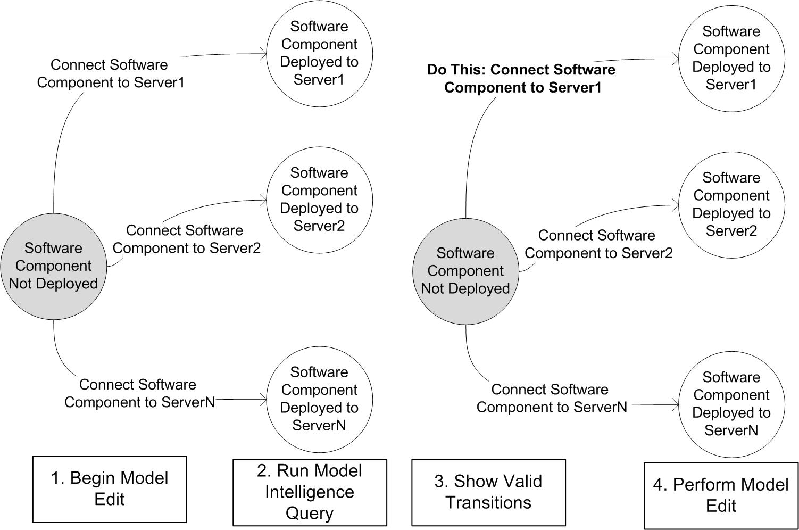

Figure 3. Model Editing Sequence for Model Intelligence

Each relationship has four key properties that are needed to derive valid endpoints. First, a relationship has a source and a target. Furthermore, each relationship has a source type and target type, governing the types of modeling elements that can participate in the relationship. Once Model Intelligence knows the source object and the OCL constraints on the relationship being modified, a query can be issued to find valid endpoints to complete the relationship. Using the OS deployment constraint from Section 4, if a deployment relationship was being modified and its source SoftwareComponent had been specified, Model Intelligence would issue the query:

Server.allInstances()->collect(target |
target.OS = source.OS);

In the above example, Model Intelligence would specify to the OCL engine that the source variable mapped to the SoftwareComponent that had already been set as the source of the deployment relationship. The query would return the list of all Servers that had the correct OS for the component. For an arbitrary relationship, with constraint Constraint, between elements Source and Target of types SourceType and TargetType, a query can be composed to derive valid endpoints. Assuming that a relationship has endpoint Source set, a query can be issued to find potential values for Target as follow:

TargetType->allInstances()->collect(
target | Constraint);

where Constraint is a boolean expression over the source and target variables. More generally, the query can be expressed as:

Find all elements of type TargetType where Constraint holds true if the source is Source.

3.3 Endpoint Derivation Across Multiple Constraint Languages
As we showed in Section 4.2, given an endpoint Source, a TargetType, and a Constraint over the relationship being modified, a general query definition can be produced. Although we have only focused on OCL thus far, this generalized query definition can be mapped to other constraint or expression languages as well. In prior work, we have implemented Model Intelligence using OCL, Prolog, BeanShell, and Groovy. Prolog, for example, naturally defines a knowledge base as a set of facts defined using predicate logic. Queries can be issued over a Prolog knowledge base by specifying constraints that must be adhered to by the facts returned.

Model Intelligence can also be used to derive solutions that are restricted by a group of constraints defined in multiple heterogeneous languages. The key to enabling modeling guidance constraints defined in heterogeneous languages is to provide a mechanism for iteratively filtering out query results across the languages, as shown in Figure 4.
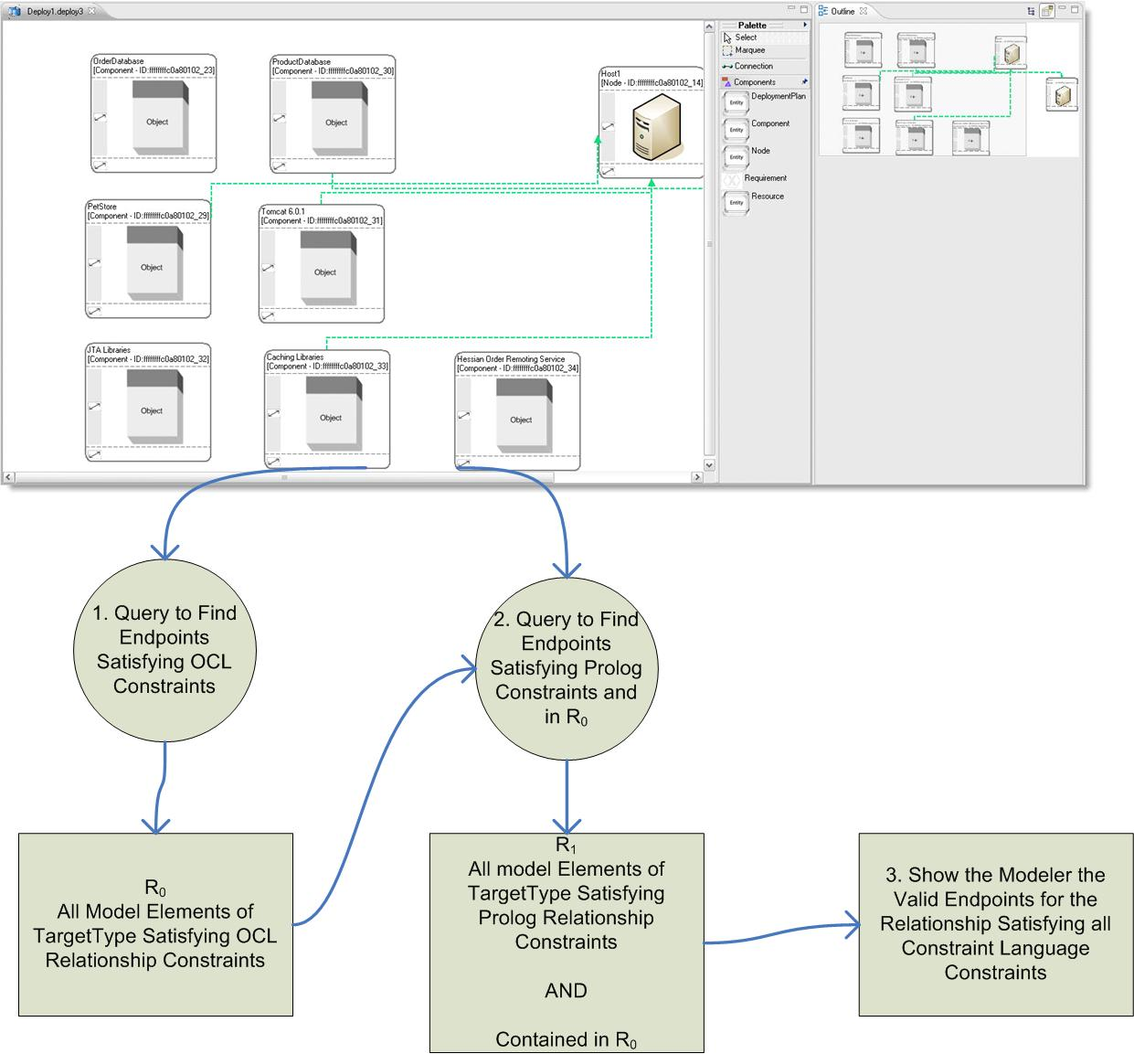

Figure 4. Model Intelligence Queries Across Multiple Constraint Languages

Initially, Model Intelligence issues a query to derive potential solutions that respect the constraint set of one constraint language. The results of the query are stored in the set R₀. For each subsequent query language C_{i}, the results of the query to satisfy the language’s constraint set are stored in R_{i}. For each constraint language C_{i} where i > 0, Model Intelligence issues a query using a modified version of the query format defined in Section 4.2:

Find all elements of type TargetType where Constraint holds true if the source is Source

AND

the element is a member of the set R_{i-1}

The modified version of the query introduces a new constraint on the solution returned—that all elements returned as a result were a member of the previous result set. A simple mechanism for specifying result sets is to associate a unique Id with each modeling element and to capture query results as lists of these IDs. The modified queries can then be defined by checking to ensure that both the constraint set holds and that the ID property of each returned modeling element is contained by the previous result set.

4 Integrating Model Intelligence with the Command Pattern

There are a large number of uses for Model Intelligence, ranging from automatically performing a batch process of changes to bring a model to a desired state to providing visual feedback to a modeler. In this section, we show how Model Intelligence can be integrated with the Command Pattern to provide visual queues to aid a modeler in correctly completing modeling actions. The Command Pattern is used in the implementation of a large number of graphical modeling frameworks, such as the Eclipse Graphical Editor Framework.

The Command Pattern encapsulates the logic and data needed to perform a modeling edit in a command object. As a modeler edits a model, commands are created and executed on the model to carry out the actions of the modeler. Commands are often stored on a stack so that they can be undone if needed.

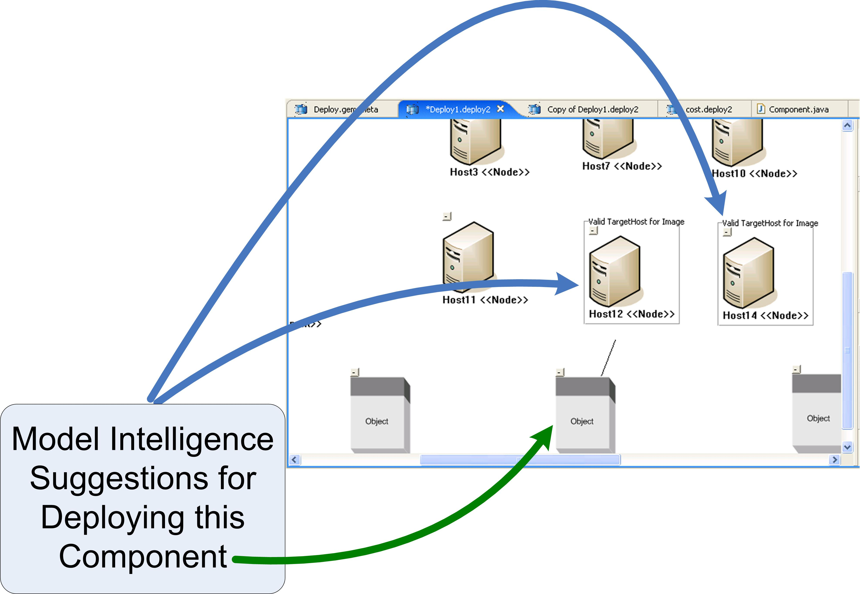

Figure 5. The Deployment Command Showing Valid Endpoints Derived via Model Intelligence

Modeling platforms provide a number of tools, such as a connection tool, that can be used by the modeler to perform actions. Each tool is typically backed by an individual command object, such as a connection command. When a user chooses a tool, an instance of the corresponding command class is created. Subsequent pointing, clicking, and typing by the user, sets the arguments (e.g., connection endpoints) operated on by the command. When the arguments of the command are fully specified (e.g., both endpoints of a connection command are set), the command is executed.

Section 3 laid out the goal of being able to highlight the valid deployment locations for a software component after a modeler clicked on it to initiate a deployment connection. This functionality can be achieved by combining Model Intelligence with a deployment connection command. After the initial argument to the deployment connection command is set, the command can use Model Intelligence to query for valid deployment locations for the endpoint of the command. If there is a single server that can host the component, the command can autonomously choose it as the deployment location and execute. If there is more than one potential valid host, each host can be highlighted to by command to help the user select the command’s final argument.

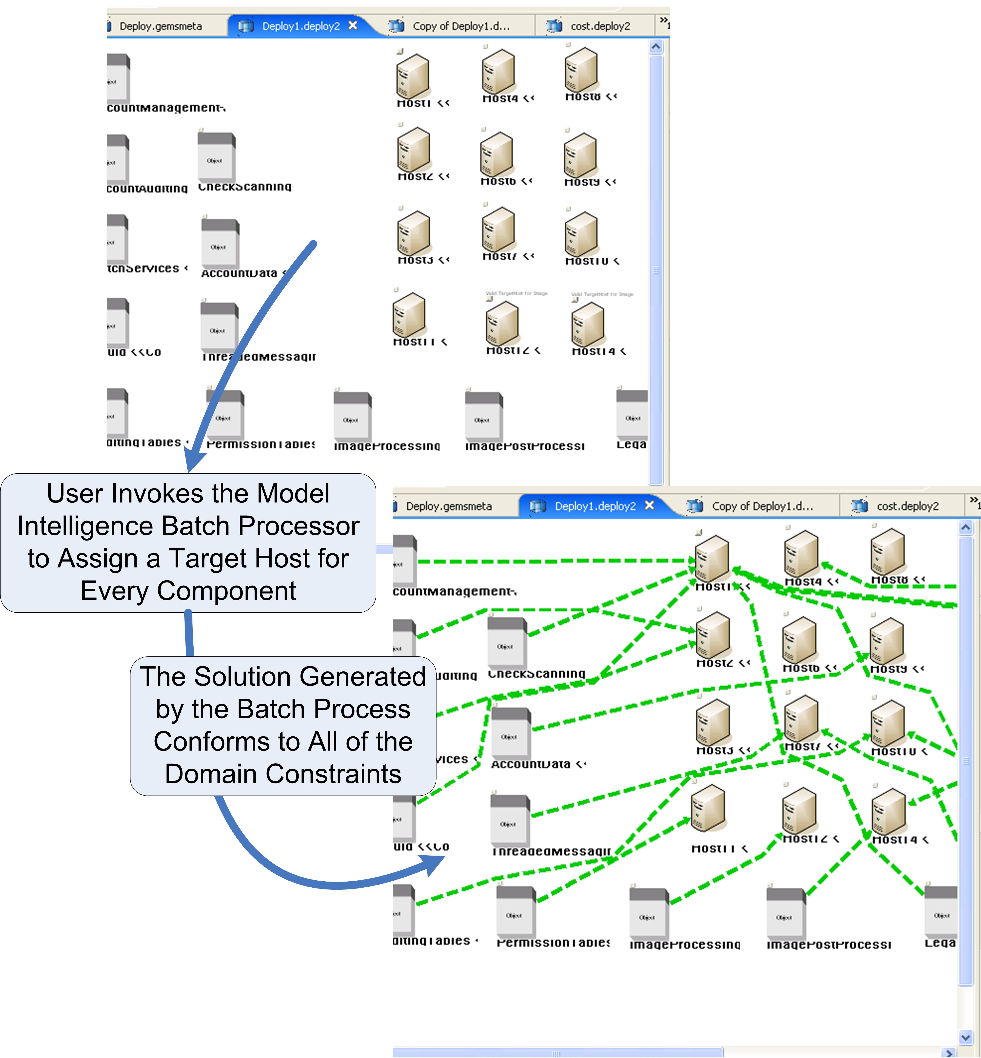

Figure 6. A Model Intelligence Batch Process to Assign a Host for Every Component

5 Conclusion
From our experience developing models for enterprise application domains, we have found that simply being able to determine if a model is correct is not always helpful. We have learned that using constraints to verify the correctness of relationships between objects rather than individual object states, allows the modeling tool to guide the modeler towards correct solutions by suggesting ways of completing edits. Furthermore, batch processes can be built on top of suggestion mechanisms to allow the tool to autonomously complete modeling actions, such as deploying a large group of software components, by deriving valid endpoints for a set of relationships and intelligently selecting relationship endpoints, as shown in Figure 6. In other work, we have used Model Intelligence as the basis for creating batch modeling processes that use constraint solvers to not only automatically construct correct models but to optimally select endpoints for relationships to satisfy global constraints or optimization goals.

Our implementation of Model Intelligence for the Eclipse Modeling Framework, call GEMS EMF Intelligence, is an opensource project available from: http://www.eclipse.org/gmt/gems.

