SUMMARY AND CRITIACAL EVALUATION OF J2EE ARCHITECTURE

Completed by

Arvind S Krishna 90086152

Jaiganesh Balasubramanian 75727683

Introduction

As we approach the new millennium, businesses are faced with ever increasing competition. Every business has to figure out new ways to produce better products in less time and cost, to devise better ways to attract and retain customer and to find better ways to adapt its products and services as fast as possible to maintain a competitive edge.

In response, many companies are turning to electronic business solutions and in short “Enterprise Applications”. Electronic business can open up new channels to increase revenues. Business2Business E-commerce can streamline supply chains to improve efficiency. But E business also adds a significant level of complexity to enterprise systems:

- Enterprise Applications now need to reach out well beyond the confines of the traditional corporation.
- Companies must now integrate their internal systems to a network of other systems. Computer networks typically are heterogeneous, for e.g. the internal network of a small network company may be made of multiple computing platforms. There may be a main frame that handles transactional database access for order entry, Unix workstations that supply hardware simulation environments and a software development backbone, personal computers that run windows and other specialized systems such as network computers etc.
- Enterprise application systems must be able to support hundreds of thousands to millions of concurrent users.
- Enterprise application systems must be available all the time, hence system administration activities must be scheduled even when the system is active.
- Since an Enterprise applications system interacts with many other systems, any one on the Internet can potentially infiltrate the system, hence enterprise systems require different methods to identify and authenticate users, guard against unauthorized use of the systems and protect the integrity of the data. In addition these application must protect the privacy of customers.

The Java 2 platform, Enterprise Edition, is designed to support the rigorous requirements of modern, extended, E-business-oriented, enterprise application systems. J2EE provides component –based, server-centric, multi-tier application architecture.

Developing server components is difficult because in addition to writing the application logic must account for numerous server-side issues such as Threading, Concurrency, Security, and Authorization etc. Most developers agree that it is very difficult to develop a server rather than a client. Hence a Server component model is required. The technologies within J2EE that address server-side development needs are

- Enterprise Java Beans, which are used for building Server side components. It allows the developer to focus only on the application logic taking care of the system programming needs.
- Java Servlets, which provide the means for interaction with clients.
- Java Server Pages, which allow developers to create dynamic content for thin clients.

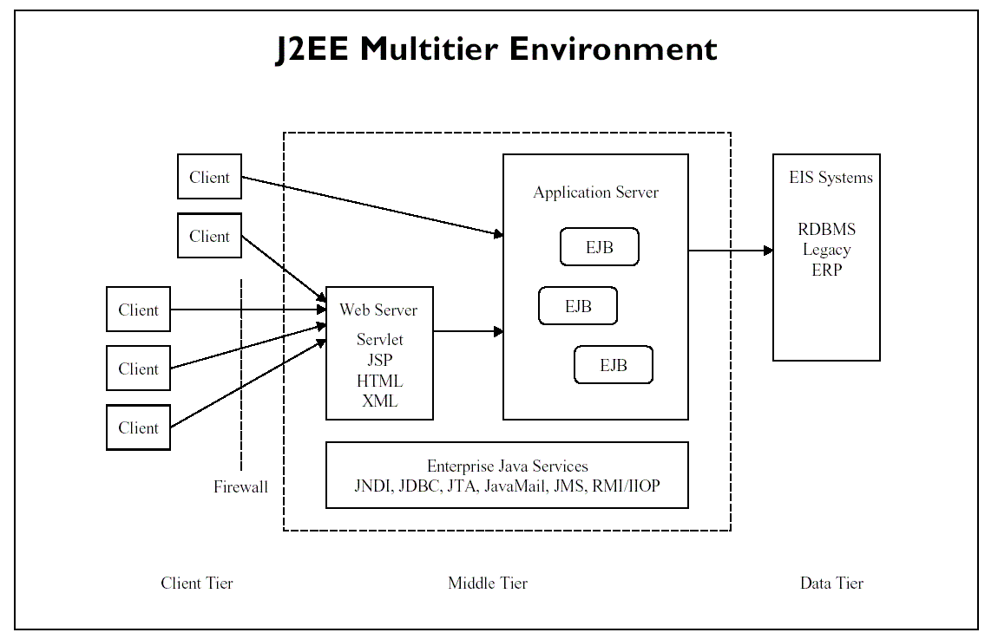
Figure1: J2EE Multi Tier Architecture

Enterprise Java Beans

Enterprise Java Beans is a specification for creating server-side scalable, transactional, multi-user secure enterprise-level applications. It provides a consistent component architecture framework for creating distributed n-tier middleware. It would be fair to call a bean written to EJB spec a Server Bean. A typical EJB Architecture consists of
An EJB server
EJB containers that runs on these servers,
EJBs that run in these containers,
EJB clients and
other auxiliary systems like
the Java Naming and Directory Interface (JNDI) and the Java Transaction Service (JTS).
In a typical development and deployment scenario, there will be an EJB server provider who creates and sells an EJB server along with EJB containers that will run on these servers. Then there will be the EJB providers-people responsible for developing the EJBs and the Application assemblers-people that use pre-built EJBs to build their applications.
EJB Servers:
These are analogous to the CORBA ORB. This provides the system services like a raw execution environment, multiprocessing, load balancing, device access, provides naming and transaction services and makes containers visible.

EJB Containers:
These act as the interface between an Enterprise Java Bean and the outside world. An EJB client never accesses a bean directly. Any bean access is done through container-generated methods, which in turn invoke the bean's methods. The two types of containers are session containers that may contain transient, non-persistent EJBs whose states are not saved at all and entity containers that contain persistent EJBs whose states are saved between invocations.

EJB Clients:
These make use of the EJB Beans for their operations. They find the EJB container that contains the bean through the Java Naming and Directory (JNDI) interface. They then make use of the EJB Container to invoke EJB Bean methods.

Enterprise Java Beans:
There are two types of EJBs. They are Session Beans and Entity Beans

Session Beans:
Each Session Bean is usually associated with one EJB Client. Each Session Bean is created and destroyed by the particular EJB Client that it is associated with. A Session Bean can either have states or they can be stateless. However, Session Beans do not survive a System shutdown.
Entity Beans:
Entity Beans always have states. Each Entity Bean may however be shared by multiple EJB Clients. Their states can be persisted and stored across multiple invocations. Hence they can survive System Shutdowns.

Java Servlets

Servlets are server-side Java programs that are loaded and run within the framework of a web server.
They are often compared to "applets", which are client-side Java programs that are loaded and run with within the framework of a web browser.

The three phases of the servlet life cycle are
- Initialization: accepts configuration and initializes the state;
- Service: processes zero or more user requests and returns output; and
- Destruction: final preparations for shutdown and release of memory resources.
Servlets can be compared to CGI programs.
While CGI programs can be written in Java, Java servlets add additional functionality including security, dynamic loading from remote servers, and the ability to add functionality to your web server. Unlike CGI programs, servlets are loaded once and then stay resident. Future service
calls to the servlet are faster since the servlet is already in memory. Servlets can maintain state information between service calls. Most major websites web servers support the Servlet APIs.

Java Server Pages

Java Server Pages (JSP) is a technology that lets you mix regular, static HTML with dynamically generated HTML. Many Web pages that are built by CGI programs are mostly static, with the dynamic part limited to a few small locations. But most CGI variations, including servlets, make you generate the entire page via your program, even though most of it is always the same. JSP lets you create the two parts separately.

Concluding Remarks

Recent advances in technology have lead to the development of “The CORBA Component Model CCM” which is a specification for creating server-side space, scalable, language-neutral, transactional, multi-user and secure Enterprise-level applications. It provides a consistent component architecture framework for creating distributed n-tier middleware. A typical CCM Architecture consists of
CCM Containers, CORBA components that run in these containers, The Portable Object Adapter (POA), The Object Request Broker (ORB) Other CORBA object services like CORBA Transactions, CORBA Security, CORBA Persistence, etc.

The main distinctions between EJB and CORBA are on flexibility and focus:
- CORBA is language and platform neutral whereas EJB is Java and JVM specific.
- CORBA’s POA/Servant model is more flexible than the EJB Container/Bean model.
- EJB tends to better support the deployment environment with the strong notion of configuration.
- While CORBA does not say much about configuration, some ORB products are particularly strong in this area.

Distributed applications can be developed using both CORBA and EJB. For example, a client application might be developed to access a set of EJB and CORBA objects without distinction. There are some differences in the interface design patterns in the two environments, but there are straightforward to handle. The difficult architectural problems of distributed computing are still difficult, regardless of which technology is used. These problems reflect more on determining how the system should represent interfaces rather than how to act on those interfaces. The CORBA and EJB environments can naturally interoperate at the network level. Core Java and EJB distributed computing uses Java Remote Method Invocation (RMI) for the network protocol. CORBA’s IIOP and Java’s RMI are compatible in the sense that IIOP can carry RMI-based calls.

