Report on
Patterns for Concurrent Networked Objects
Distributed Software Architecture Design ECE 255
Department of Electrical and Computer Engineering

Arvind S Krishna 90086152
JaiGanesh Balasubramanian 75727683
Introduction Patterns and Frameworks:
Mature engineering disciplines have handbooks that describe successful solutions to known problems. For instance, automobile designers don't design cars using the laws of physics. Instead, they reuse standard designs with successful track records. The extra few percent of performance available by starting from scratch typically isn't worth the cost.
The theme of this issue is ``patterns'' and ``pattern languages'', which are an attempt to describe successful solutions to common software problems. The long-term goal is to develop handbooks for software engineers. Though we are a long way from that goal, patterns have proven useful in the short term to help people reuse successful practices. Not only do patterns teach useful techniques, they help people communicate better, and they help people reason about what they do and why. In addition, patterns are a step toward developing mature handbooks for software engineers to help in reducing the development time.
Patterns capture the static and dynamic structures and collaborations of successful solutions to problems that arise when building applications in a particular domain. A framework is an integrated set of components that collaborate to provide a reusable architecture for a family of related applications. Both patterns and frameworks help developers communicate architectural knowledge, help people learn a new design paradigm or architectural style, and help new developers ignore traps and pitfalls that have traditionally been learned only by costly experience.
Patterns represent recurring solutions to software development problems within a particular context. Patterns and frameworks both facilitate reuse by capturing successful software development strategies. The primary difference is that frameworks focus on reuse of concrete designs, algorithms, and implementations in a particular programming language. In contrast, patterns focus on reuse of abstract designs and software micro-architectures.
Frameworks can be viewed as a concrete reification of families of design patterns that are targeted for a particular application-domain. Likewise, design patterns can be viewed as more abstract micro-architectural elements of frameworks that document and motivate the semantics of frameworks in an effective way. When patterns are used to structure and document frameworks, nearly every class in the framework plays a well-defined role and collaborates effectively with other classes in the framework.
The ACE Framework:
The ADAPTIVE Communication Environment (ACE) is a freely available, open-source object-oriented (OO) framework that implements many core patterns for concurrent communication software. ACE provides a rich set of reusable C++ wrapper facades and framework components that perform common communication software tasks across a range of OS platforms. The communication software tasks provided by ACE include event demultiplexing and event handler dispatching , signal handling , service initialization , interprocess communication , shared memory management, message routing , dynamic (re)configuration of distributed services , concurrent execution and synchronization
ACE components are designed using many key patterns that increase key qualities, such as flexibility, extensibility, reusability, and modularity, of communication software.
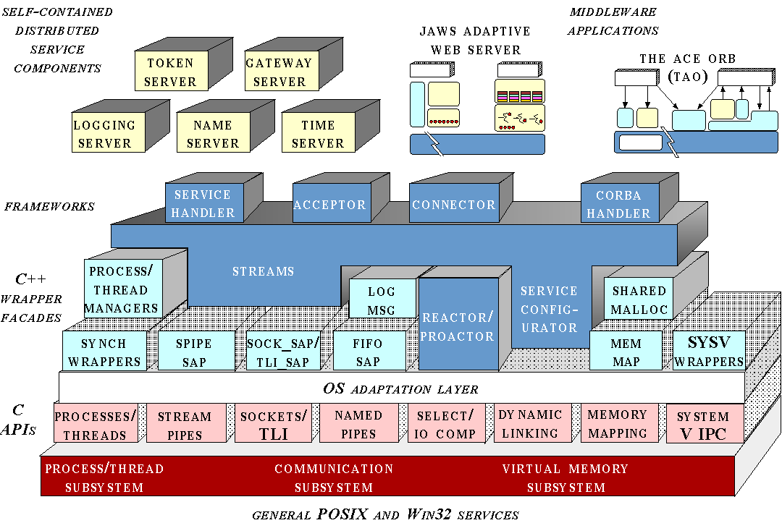

Figure 1: The ACE Framework

Figure 1 shows the layers and components in the Ace framework. The ACE encapsulates several of the low level function calls and APIs into well defined wrapper facades, these wrapper facades provides a uniform interface that are operating system independent. ACE has been ported to several operating systems e.g Linux SunOS, Windows etc.

In the next section we present three design patterns that are widely used in Distributed Systems.

Wrapper Façade Design Pattern:

- Contex

A Web server must manage a variety of OS services, including processes, threads, Socket connections, virtual memory, & files. Most operating systems provide low-level APIs written in C to access these services.

- Problem:

Implementing advanced services requires utilizing lower-level functionality. Many low-level APIs differ in syntax, even if they share semantics. Nonetheless, Applications should be portable to different platforms hence direct dependencies from APIs should be avoided. •Applications should use these APIs correctly and consistently.

- Solution:

The Wrapper Facade design pattern encapsulates the functions and data provided by existing non-object-oriented APIs within more concise, robust, portable, maintainable, and cohesive object-oriented class interfaces
A Client invokes a method on the wrapper façade. The wrapper delegates the execution of this method to a function that represents a low level API

Figure 2 Dynamics of the Wrapper Façade Pattern

ust be able to handle request even if they are waiting for other requests to arrive.
Reactor Design Pattern:

- Context and Problem:
Developers often couple event-demuxing & connection code with protocol-handling code. This code cannot then be reused directly by other protocols or by other middleware & applications Thus, changes to event-demuxing & connection code affects the server protocol code directly & may yield subtle bugs.

- Solution:
Use the Reactor Design Pattern to decouple event demultiplexing code from the protocol handling code. Concrete event handlers register with the reactor for specified events.
The reactor requests each event handler to pass back its handle. The event handling is started. The Reactor calls the synchronous event demultiplexer to wait for events to occur on the handles. The synchronous even demultiplexer notifies the Reactor when the handle becomes ready. The reactor triggers the event handler represented by the handle to process the event. The event handler processes the event.
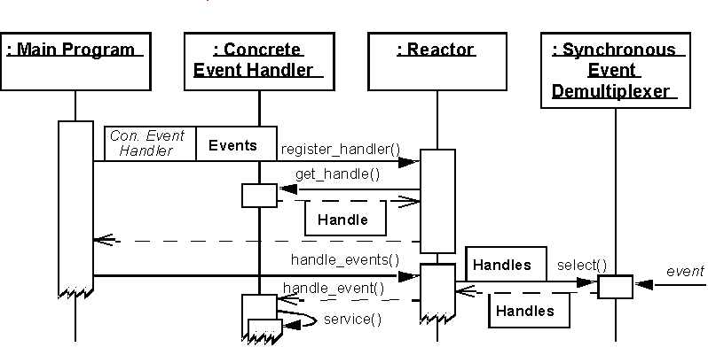

Figure 4: Dynamics of the Reactor Design Pattern

Half Sync Half Async Design Pattern:

- Context:
HTTP runs over TCP, which uses flow control to ensure that senders do not produce data more rapidly than slow receivers or congested networks can buffer and process
Since achieving efficient end-to-end quality of service (QoS) is important to handle heavy Web traffic loads, a Web server must scale up efficiently as its number of clients increases

Problem
:
Processing all HTTP GET requests reactively within a single-threaded process does not scale up, because each server CPU time-slice spends much of its time blocked waiting for I/O operations to complete
Similarly, to improve QoS for all its connected clients, an entire Web server process must not block while waiting for connection flow control to abate so it can finish sending a file to a client.

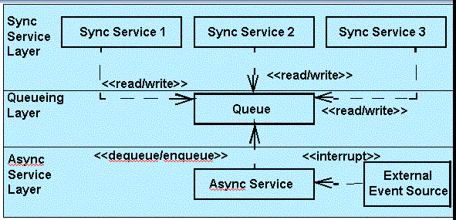

Solution
The Reactor dispatches events arriving at event sources asynchronously to appropriate event receivers. The Event Receivers read the events and insert them into a Message Queue. These happen independently of any service processing. Application services run in their own thread of control and block on the message queue until an event they can process arrives. The application services process the events and generate output that is either returned to the sender of the original event or to a designated receiver.

Summary and Conclusions:

Mature engineering disciplines have handbooks that describe successful solutions to known problems.

• e.g., automobile designers don’t design cars using the laws of physics, they adapt adequate solutions from the handbook known to work well enough.

•
The extra few percent of performance available by starting from scratch typically isn't worth the cost.

•Patterns can form the basis for the handbook of software engineering.

•
If software is to become an engineering discipline, successful practices must be systematically documented and widely disseminated.
Reference:

1: The ACE Framework: http://www.cs.wustl.edu/~schmidt/ACE.html

2: TAO (The ACE ORB) http://www.cs.wustl.edu/~schmidt/TAO.html
3: The Reactor Design Pattern: Pattern Languages of Programming Design
4: Design Pattern: The Gang of Four Book
5: The Half Sync and Half Async Design Pattern: Pattern Oriented Software Architecture 2.
6: www.posa.uci.edu POSA II book reference.

