ICS 243A Computer Networks

ALPAC

Application Layer Protocol for Agent Communication

A protocol design document developed as part of course work in Computer Networks course – ICS 243A.

Protocol design team:

Arvind S. Krishna
Dawit Yimam Seid
Sumita Rao
Sundararajan Sowrirajan

Department of Information and Computer Science
University of California, Irvine
March 2001

Table of contents:

- Introduction 3

- Architecture of the System 5
  - Client side 5
  - Server side 6

- ALPAC Protocol 8

- Naming Conventions 14

- Assumptions for Implementation 15

- References 16

- Introduction

Agents – this word holds different meanings in different scenarios. In the context of computer systems, Agent is a theoretical concept in the area of Artificial Intelligence. It’s a long lived computational system which has goals, sensors and effectors and decides autonomously which actions to take in the current situation to maximize progress towards its time-varying goals [1]. There are different types of agents: autonomous robots, expert assistants, software agents / knowbots / softbots. The focus of our document is on SOFTWARE AGENTS.

Software agents are types of agents that inhabitate computers and networks and assists the users in carrying out various tasks [2].

User

Application
Agent
Interacts with
Interacts with
collaborates

Agents are personalized and customized software applications which are pro-active, take initiative, autonomous and adaptive. In the era of Internet, the World Wide Web offers infinite amount of information. An ordinary user is unable to locate the information he needs and is untrained to derive the maximum benefit from the wealth of information.
Agents offer a means by which the needs, wants and preferences of the users are captured and the user is freed of the actual activity. The agents are delegated the activity, which accomplish tasks on behalf of the user, based on the users preferences. Common tasks like making airline reservation based on the best deal offered by all the airlines can be delegated to agents. Since agents can be personalized, they can be very effective is assisting the users based on their personal preferences.

Based on the nature of the tasks performed, software agents can be classified as User agents and Service agents. User agents are those that assist users in performing personal tasks and know the user preferences, like personal e-shopper agent etc. Service agents are the more generic agents that perform servicing tasks (to other user agents or to users) like information retrieval etc. In the context of client server architecture, the user agents can be assumed as the clients and the service agents can act as the server.

Agents can either be stationary or mobile. Stationary agents can reside at the client machine and server machine and can interact with one another. Mobile agents move from client to server to another server and finally to the client. The scope of our document is restricted to the stationary agents.

In interaction between stationary agents, some aspects need to be dealt with, like, finding other agents, common communication method, identification and authentication etc. In effect, we need a protocol for the agents to interact with one another. There needs to set of defined operations, message formats for the agents to interact with one another. ALPAC is such an attempt to solve the communication problem between agents. ALPAC stands for Application Layer Protocol for Agent Communication.

This document provides a description of the protocol, the format of the messages exchanged, the underlying operations and means for extension. We are very grateful to MIT Agents lab for providing fundamental knowledge of agent based systems (http://agents.www.media.mit.edu/groups/agents/) and to FIPA (www.fipa.org) for providing invaluable insight into protocol definitions for agent based systems.

- Architecture of the System
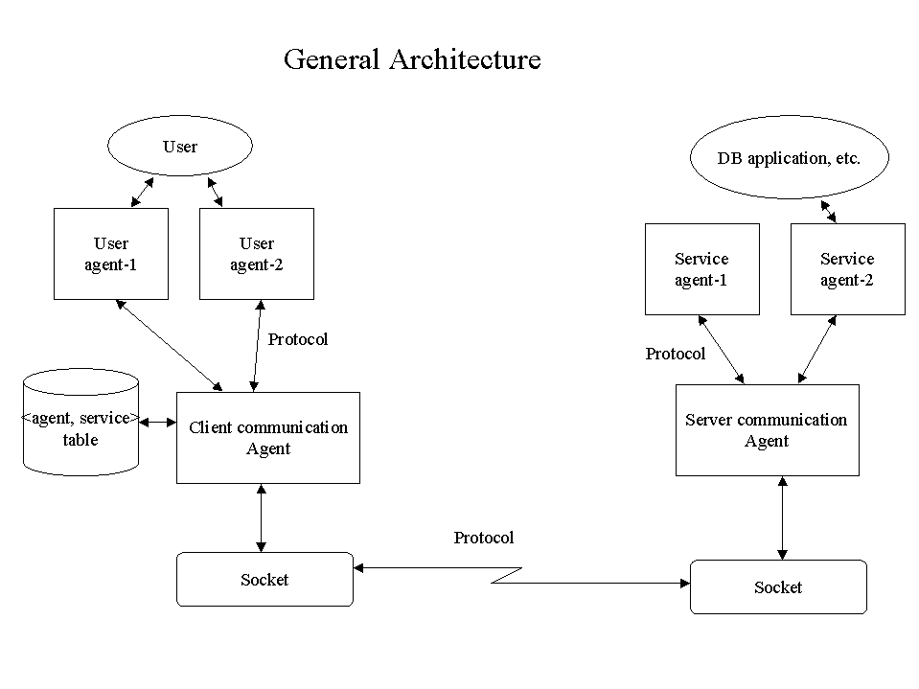
There are two distinct sides to the communication between agents – those that request services, namely the user agents, act as the client side and those that service these requests, namely the service agents, act as the server side.

2.1 Client side:

User agents:
There can be different types of user agents providing different kinds of services to the user. For instance, there can be agents for assisting the user with airline ticket reservation, agents for monitoring stock prices and so forth. There can also be more than one instance of a particular agent. The user agents offer GUI to the user to capture his requests and preferences, like in the case of Air Travel User Agent (ATUA) travel dates and destination, preferred price range and so forth are captured from the user. The user interacts only with user agent.

Client Communication Agent (CCA):
The user agent, after receiving the information from the user, sends it in a specified format to the CCA. The format of the message is dependent on the application. For instance, the ATUA may send a message in the following format:

Travel from : Los Angeles, USA
Travel to : London, England
Round-trip : No
Date : 04/02/2001, 04/03/2001
Time : any
Fare : USD 350 – 400
Priority : date

The above message is specific to the domain of airline ticket reservations. Since agents are custom made and also since information format and content varies from domain to domain, an attempt to have a generic content format is not an effective approach. Agents can be developed for any new domain by designing just the content format and by registering the user agent with the CCA. This content format does not in any way influence the communication between the agents. This is transparent to the user agent and is taken care of by the CCA.

CCA is a simplified embodiment of an agent platform which, in reality, constitutes message transport system, directory facilitator and agent management system. Actually, it is even more than this since it also relieves the user agents from any communication-oriented tasks including knowing which agent to communicate and so forth.

The CCA receives the content from the user agents. A single CCA caters to a lot of user agents. The user agents and the CCA can reside in the same machine or can be distributed. In case they are in the same machine, then user agents can invoke the CCA through function call interface; if they are distributed, then one of the methods for distributed communication like sockets or Java RMI can be used. CCA maintains two permanent directories. One is the list of agents that communicate through it (registered to it), and the list of service agents which it traces using the "rfp" request, which will be discussed in the protocol section of this document. A CCA has to have functionality both to give a "yellow page service" when others request it about the its agents (agents registered to it) and to ask other communication agents to tell it about their agents (e.g. the services they provide). Note also that the latter is our adaptation and would not be necessary in real case. In practical applications, rather than maintaining its own list, the CCA can contact a central or distributed directory server, similar to DNS, to find the service agents. The CCA also assigns an unique identification for each message it receives from the user agents. Its stores this id along with the message details, like which user agent requested it and so forth. This helps the CCA to keep track of the requests and to deliver the response to the requesting user agent.

The CCA formulates the protocol message and includes the message received from the user agent in the content part of the protocol message. The structure of the protocol message is described in the protocol section of the document. CCA initiates a connection with the Server Communication Agent (SCA), using sockets.

  - Server side:

Server Communication Agent (SCA):
The SCA listens to the port (details given in protocol section) for requests from CCAs. When it receives a message from CCA, it stores the request and strips the content from the protocol message. Based on the parameters, like receiver, in the protocol structure (details in protocol section), the SCA passes the content to the appropriate server agent which would process it. After SCA receives a response from the service agent, it re-formulates a protocol message with the response as the content and sends it back to the CCA, which requested it. The entry in the table for the request is deleted. The unique identifier of the message, which is generated by the CCA and included in the protocol message format, is used along with requesting agent’s name by the SCA to keep track of the requests it receives. A single SCA can handle requests for many different service agents. Like CCA-user agent relation, SCA-service agents can be on the same host or can be distributed. In the extended version of the project, attempt must be made to wherein a CA can act as both as a SCA as well as a CCA based on the role of the agent associated with it.

Service Agent:
The software agents that reside at the server side and provide various specialist services like air travel details, stock quotes are called as server agents. These agents have access to the local resources of the host/server like database. The SCA delivers the request to the service agent, which is registered with it and deals with that kind of request. For instance, a request from a ATUA would be handled by a ATSA – Air Travel Service Agent. The ATSA would understand the format of the request from ATUA. The service agent does the actual processing of the request and hides these details from SCA and other entities of the system. The response is formatted and sent back to the SCA. If the service agent is not able to understand the request or if data is not available, it generates an error message.
The response for the instance given in user agent can be like:

Travel from : Los Angeles, USA
Travel to : London, England
Round-trip : No
1
Airlines : Delta Airlines
Date : 04/02/2001
Time : D – 0430; A - 1130
Fare : USD 375.45
2
Airlines : Delta Airlines
Date : 04/03/2001
Time : D – 0330; A - 1030
Fare : USD 383.45
3
Airlines : American Airlines
Date : 04/02/2001
Time : D – 0230; A - 0930
Fare : USD 390.00
--

- ALPAC Protocol

The ALPAC protocol is a simple protocol that enables different types of agents to talk with one another. Whenever a new agent application needs to be introduced, the following needs to be done:
- Design a format for the message content of the new agent application, based on the domain. This message format would be domain specific and thus provides the flexibility of designing message formats, which best suit the application. The request message format as well as the response message format needs to be defined. The semantics of the fields in the messages also need to be defined.
- The new agent type needs to be registered with the communication agent. The user agent must be registered with the CCA through which it would communicate and the service agent must be registered with the SCA from which it would receive requests. The Agent Registration Request Protocol (ARRP) is defined to deal with this. ARRP is described later in this section.

Air Travel Agent example:

In case of ATA, the ATUA would formulate a message based on the following structure:

ATA request {

Travel from : <departure city/airport code, country>
Travel to : <arrival city/airport code, country>
Round-trip : < boolean>
if yes {
Onward Travel {
Date : <date of travel>
Time : < preferred time range for departure or any>
Fare : <preferred fare range in USD or any>
Priority : <date/time/fare/none>
}
Return Travel {
Date : <date of travel>
Time : <preferred time range of departure or any>
Fare : < preferred fare range in USD or any >
Priority : <date/time/fare/none>
}
}
else {
Date : <date of travel>
Time : <preferred time range of departure or any>
Fare : < preferred fare range in USD or any >
Priority : <date/time/fare/none>
}
}

ATA response {

Travel from : <departure city/airport code, country>
Travel to : <arrival city/airport code, country>
Round-trip : <boolean>
if yes {
Onward Travel {
{
<option number>
Date : <date of travel>
Time : < preferred time range for departure or any>
Fare : <preferred fare range in USD or any>
Priority : <date/time/fare/none>
} (repeats for all options)
-- (indicates end of options)
}
Return Travel {
{
<option number>
Date : <date of travel>
Time : <preferred time range of departure or any>
Fare : < preferred fare range in USD or any >
Priority : <date/time/fare/none>
} (repeats for all options)
-- (indicates end of options)
}
}
else {
{
<option number>
Date : <date of travel>
Time : <preferred time range of departure or any>
Fare : < preferred fare range in USD or any >
Priority : <date/time/fare/none>
} (repeats for all options)
-- (indicates end of options)
}

Header:
The CCA would formulate a protocol message format with the user agent message as the content. This format is generic to all agent applications and is not domain specific. It’s the responsibility of the CAs – CCA and SCA to formulate a domain independent request/response from a domain specific user agent message/response.

Request message format:

{ communication act / performative
: sender
: receiver
: reply-to
: reply-with
: content
: language
}

Response message format:

{ communication act / performative
: sender
: receiver
: in-reply-to
: reply-by
: content
: content-length
: language
}

The communication act/performative is the request/response verb that forms the main command of the request/response. (It is similar to GET, POST methods of HTTP).
The communication acts in ALPAC are:
- Request – this is the method used by the CCA to request information from a SCA. This is the fundamental and most common method that will be used during communication among agents. Its like the GET method of HTTP in its role and significance.
- Inform – this is the response method used by a SCA when it is replying to a ‘request’ method from the CCA. This is used as part of the response generated by the SCA for a CCA request. So, Inform methods are associated with request methods.
- Failure – this is the method used by SCA when responding to a wrong or unintelligible request from a CCA. The error message forms the content and the communication act is failure. Failure methods are also associated with some request methods.
- CFP – this method is used by the CCA to find out about the various service agents supported by a SCA. When a new agent is registered with a CCA, it sends out a CFP or Call for Proposal to specified SCAs to find out about the service agents for the new user agent. The CCA can also send out general CFPs to SCAs to find out about the list of service agents supported by the SCAs. The list of SCAs which a CCA contacts for CFP can be either through a central directory service or the URLs of the SCAs may be provided to the CCA. In our model, when the new user agent service is being registered with the CCA, the URLs for CFP are also provided.
- Proposal – the response generated by the SCA in reply to a CFP is called the proposal method. Proposal methods are, hence, associated with a CFP request.

The fields:

- Sender – This field identifies the sender user agent. It provides the name of the agent (refer naming section of this document) which has generated this request.
- Receiver – This field indicates the intended recipient of the request generated. It holds the name of the service agent, which is expected to service this request.
- Reply-to – If a different agent expects the response, than the agent generating the request, that recipient is indicated here. This is to handle situations where a master user agent might request specific user agents to request information and then the response for all these requests would be taken by the master user agent for processing. If this field is blank, then sender value is assumed as default.
- Reply-with – This field contains the unique message identification generated by the CCA while formulating the protocol format request message. This is used by the SCA to keep track of the requests from the same CCA. This is included in the request message.
- In-reply-to – This field is the response message version of Reply-with field in the request message. This is included by the SCA for the CCA to identify the request for which the response has been generated.
- Reply-by – This is the timestamp of the time when the SCA formulates the response message.
- Content – This is the actual message supplied by the user agent to the CCA or the response message provided by the service agent to the SCA. Content has the domain specific information in domain specific format. This is the ‘payload’ part of the protocol message packet.
- Content-Length – The length of the associated content. This is used to identify the end of content of the message / payload.
- Language – If any specific language is used for formulating the content, then that needs to be indicated using this field. This is domain specific information. This has been included with future extensions in mind. There can be specific types of agents, which use specific language to communicate. This field is similar to the content-type field of the HTTP response message.

Error Messages:

The following error messages are generated in this protocol:

‘ Service agent not available’ – This error is generated when a SCA does not have a service agent registered with it to handle the request from a CCA.
‘ Invalid request’ – If the message from the user agent does not fit the required format and stipulations expected by the corresponding service agent, then this error is raised.
‘ Data Unavailable’ – If the service agent is not able to provide meaningful response to a request, due to unavailability of data requested or inaccessibility of data resources etc, this error is raised.

These error messages can have associated numbers/codes for easy identification.

Port Number:
The port number 5555 will be used for ALPAC. The CCA communicates with SCA through port 5555. The SCA keeps listening for request and CCA keeps listening for response on port 5555. All user agents and service agents share this port as initiating and terminating a socket connection is the job of the Communication Agents (CCA and SCA).

Storage Data structures:

The list of service agents maintained by CCA, obtained through previous CFP requests:

service-agent-list
{
agent name (name of the service agent)
service (kind of service it provides)
}

The list maintained by the CCA to keep track of all the requests:

CCA-Request-table
{
mesg_id (the unique number generated for each message)
sender ( the requesting user agent)
receiver ( the target service agent)
}

The list maintained by the SCA to keep track of all requests:

SCA-request-table
{
request_id (an unique id generated by the SCA to keep track of all the requests)
mesg_id/reply-with (the unique number generated by the CCA and sent in the reply-with field)
sender (sending user agent name)
receiver (receiving service agent name)
}

ARRP:
The Agent Registration Request Protocol (ARRP) is a minor protocol between the agents and the communication agents. Whenever a new agent has to be introduced into the system, it needs to be registered with a communication agent. In case of new user agents, they are registered with CCA and service agents are registered with SCA. Unless the agents are registered, they cannot use the ALPAC protocol to communicate.

The message format is:

{ Register (operative key word)
Name: <name of the agent>
Type: <user or service>
Code: <4 letter abbreviation>
Domain: <domain of the agent like air travel>
Location-list: <list of URLs for service agents>
}

In our system, the agent is also expected to provide some URLs of service agents, which service its requests. The URLs can be obtained from some central agent repository.

- Naming Conventions

The agents have an unique Agent ID (AID). The AID constitutes the agent name. The format of a AID is:
User agent : user-agent-nameUA@CCA-dnsname
Service agent: service-agent-nameSA@SCA-dnsname

The agent name can be a short name describing the domain to which it is attached. UA indicates that it is an user agent. The DNS name of the CCA to which this agent is associated is provided after the @ symbol. In case of service agents, SA indicates service agent. The DNS name of the SCA to which this is associated is provided after the @ symbol.

The DNS names of the associated CAs are provided for easy identification of which SCA or CCA to send the information if it has to reach the agent. For instance, an air travel user agent associated with a CCA located at magneto.ics.uci.edu would be named as:
AirtravelUA@magneto.ics.uci.edu
A service agent related to this could be: airtravelSA@res.americanairlines.com

Agents are provided with 4 letter abbreviation which are used as codes to identify them. For instance the air travel user agent would have a code as ATUA and the air travel service agent would be referred to as ATSA.

The unique message id generated by the CCA when formulating a protocol format message has the following format:
XXXX/n/mm/dd/yyyy
Where XXXX is the 4 letter abbreviation code for the agent
n is the number of message being processed by the CCA on that day. This is reset everyday.
mm/dd/yyyy represents the current date.

An example would be ATUA/3/03/10/2001, which means the requester is an ATUA agent instance, this is message number 3 being handled by the CCA on 03/10/2001.

- Assumptions for implementation:

The following are the assumptions we plan to make while implementing the ALPAC protocol. The assumptions are not drawback of the protocol and can be ignored when providing a complete implementation of the protocol.

- There is only one instance of a particular type of user agent running associated to a given CCA at any point in time.
- The ARRP needs the user agent to specify some service agent locations which can service its requests.
- The user agent and CCA reside on the same host. The service agent and SCA reside on the same host
- The implementation would be done for an air travel reservation agent system.
- For the purpose of demonstrating the functioning of the protocol, the data on the server side is assumed to be static files, which the service agent accesses.

- References

We are deeply indebted to the MIT software agents lab and to FIPA. Our protocol design inspiration came to a large extent from FIPA’s specifications.

The links to the above organizations are:

http://agents.www.media.mit.edu/groups/agents/
http://www.fipa.org

[1] - http://pattie.www.media.mit.edu/people/pattie/CHI97/sld005.htm
[2] - http://pattie.www.media.mit.edu/people/pattie/CHI97/sld008.htm

Other useful references are provided in the web-site for our project:
http://www.ics.uci.edu/~ssowrira/ics243a.html

